**LIBRARY MANAGEMENT SYSTEM**

**A Python Based Desktop-Application**

**A Report submitted**

**in partial fulfilment for the Degree of**

**B.Sc**

**In**

**Computer Science (Honours)**

**Submitted By:**

**Ahin Subhra Halder (193016-21-0011)**

**Avijit Halder (193016-21-0012)**

**Abhisek Midya (193016-21-0029)**

**Atish Sarkar (193016-21-0030)**

**Pursuing in**

**Department of Computer Science**

**Syamaprasad College**

**Year of Submission: 2022**



**Syamaprasad College**

**92, Dr. Syamaprasad Mukherjee Road, Kolkata-700026**

**E-mail: - syamaprasadcollege@gmail.com**

**CERTIFICATE**

This is to certify that the project report entitled “**LIBRARY MANAGEMENT SYSTEM**” submitted to **Department of Computer Science of Syamaprasad College, Kolkata,** in partial fulfilment of the requirement for the award

of the degree of **Bachelor of Science in Computer Science** during the academic year **2022**, is a *bona fide* record of the project work carried out by Abhisek Midya, Roll No- 193016-21-0029, Reg. No- 016-1112-0281-19 under my guidance and supervision. The contents of this report, in full or in parts, have not been submitted to any other Institution or University for the award of any degree or diploma.

**_____________ ______________ ______________**

**Signature of H.O.D Signature of Project Signature of the**

**Dept. of Computer Science** **Guide** **External Examiner**

**DECLARATION**

We declare that this Project Report entitled **“LIBRARY MANAGEMENT SYSTEM”** submitted in partial fulfilment of the degree of **B.Sc. in Computer Science** under Calcutta University, West Bengal is a record of original work carried out by us under the supervision of **Prof.Aparna Kisku Hansda**, and has not formed the basis for the award of any other degree or diploma, in this or any other Institution or University. In keeping with the ethical practice in reporting scientific information, due acknowledgements have been made wherever the findings of others have been cited.

|  |  |  |  |
| --- | --- | --- | --- |
| **Sl. No.** | **Name of the Student** | **Roll No** | **Signature** |
| 1. |  |  |  |
| 2. |  |  |  |
| 3. |  |  |  |
| 4. |  |  |  |

**ACKNOWLEDGEMENT**

In the present world of competition there is a race of existence in which those are having will to come forward, succeed. Project is like a bridge between theoretical and practical working. With this willing we joined this particular project.

We are obliged to the **Department of Computer Science of Syamaprasad College Kolkata,** for giving us this initiative to do this constructive project. Then we would like to express our special thanks of gratitude to **Prof.Aparna Kisku Hansda,** our guide mentor and support system throughout this project who helped and coordinated us in every path.

Besides, we would like to thank all the teachers, friends and family members who helped us by giving us advice and support throughout the period.

**Name of all the group members:**

1. **Ahin Subhra Halder**

**2. Avijit Halder**

**3. Abhisek Midya**

**4. Atish Sarkar**

**Abstract**

Library Management System is a project which aims in developing a computerized

system to maintain all the daily work of library. This project has many features

which are generally not available in normal library management systems like

facility of user login and a facility of teacher’s login.

It has a facility of admin login through which the admin can monitor the whole system. It also provides of an online **E-library** where teachers and students can read and download the books which are available.

After logging in their accounts members can see list of books issued and its issue date and return date and, they can request the librarian to add new books by filling the **BRF** which available on the website.

The librarian after logging into his account i.e., admin account can access various reports such as members details, issue report, and book report.

This library management system has a special ability (**SITE)** sending info through email by which members can get all information through email. Also, the members will get an email remainder before 2 days of due date who did not return the book.

Overall, this project of ours is being developed to help the students as well as staff

of library to maintain the library in the best way possible and reduce the human efforts.

**KEYWORDS:**

**SITE, E-Library, BRF.**

**LIST OF FIGURES**

**DESCRIPTION PAGE NUMBER**

1. **ERD 16**
2. **DFD 17**
3. **Gantt Chart 20**
4. **Client-Side Development 22**
5. **Server-Side Development 34**
6. **E-Library 33**
7. **Testing 38**

**TABLE OF CONTENTS**

**DESCRIPTION PAGE NUMBER**

**CERTIFICATE 2**

**DECLARATION 3**

**ACKNOWLEDGEMENTS 4**

**ABSTRACT 5**

**LIST OF FIGURES 6**

**TABLE OF CONTENTS 7**

**Chapter 1. INTRODUCTION** 9

1.1 Domain Description

1.2 Motivation & Scope of Work

1.3 Limitation

**Chapter 2.** **PRE-REQUISITES 12**

2.1 Hardware Requirements

2.2 Software Requirements

2.3 Languages used

**Chapter** **3. REVIEW 13**

**Chapter 4. METHODOLOGY 14**

4.1 Problem Formulation

4.2 Design Description

**Chapter 5. IMPLEMENTATION 21**

5.1 Client-Side Development

5.2 Server-Side Development

**Chapter 6. RESULTS AND DISCUSSION 38**

6.1 Blackbox Testing

6.2 Discussion

**Chapter 7. Conclusion** **41**

**Chapter 8. References 42**

**Introduction**

This chapter gives an overview about the Domain Description, Motivation and Scope of the Work of the system.

* 1. **Domain Description:**

As the modern organizations are automated and computers are working as per the instructions of user, it becomes essential for the coordination of human beings, commodity and computers in a modern organization. This information helps the distributors to purchase or sale the products very efficiently.

In our case, Library Management System consists of list of records about the management of the details of the students and the issues going on and about some books and all. This is a Python based desktop & Google blogger-based web support. The project has two modules namely- User & Librarian. This is easy and time saving concept for better usage of the library management system.

The administrators and all the others can communicate with the system through this project, thus facilitating effective implementation and monitoring of various status.

**1.2 Motivation & Scope of the Work:**

This objective overcame all the short comings of a manual system that was used daily. This includes the following: -

1. To eliminate the paperwork in library.
2. Developed a well-organized library borrowing system.
3. Produced a well-designed and functioning system in accordance with the needs and wants of the borrowers.
4. Minimized the task and the effort being performed by both the librarian and borrowers.
5. Provided the College and the students a well-organize and well-presented reports.
6. A search column to search availability of books.
7. An Admin login page where admin can add books.

**Scope of the Work:**

Library management system is a resource planning and enterprise management software, used to operate and manage the huge amount of data generated from libraries. It is also used to track books, fines for lost books, and students or other members who have borrowed books from the library. Library management system also helps in reducing operational cost, increasing efficiency, and providing easy access to the huge amount of data available in the library.

The library management system helps a librarian to maintain all types of books, journals, newspaper’s counts, and member information including profiles, penalties, payments, and other financial transactions.

So, our Library management system includes some operations such as facility of user login and a facility of teacher’s login. It has a facility of admin login through which the admin can monitor the whole system. It also provides of an online E-library where teachers and students can read and download the books which are available.

After logging in their accounts members can see list of books issued and its issue date and return date and, they can request the librarian to add new books by filling the BRF which available on the website.

The librarian after logging into his account i.e., admin account can access various reports such as members details, issue report, and book report.

Our Library management system has a special ability (SITE Sending Information through Email) by which members can get all information through email. Also, the members will get an email remainder before 2 days of due date who did not return the book.

The global library management system market is mainly driven by rise in need for automation of library management functions to manage informational resources. Additionally, growing demand for quick access to libraries through computers, mobiles, tablets, and other digital platforms further drives the market globally. So, here we can see our project can be future proof.

**1.3 Limitation of the Work:**

1. We cannot send auto remainder to the people who have borrowed books. Admin have to login and press ‘’Send Remainder” button to send the emails.
2. We are not able to test multiple computers connect to the same web server (Xampp) so the software may not work properly multiple interconnected computers at the same time.

**Pre-Requisites**

**2.1 Hardware Requirements:**

**Processor: -** Intel Core i3 processor / Reyzen 3 processor or above.

**Ram: -** 4gb or above.

**Storage Space Required: -** 50mb.

**Monitor resolution: -** 720p / 1080p

**Internet: -** Stable broadband connection / Wi-Fi.

**2.1 Software Requirements:**

**OS: -** Windows 7/8/8.1/10/11 (Recommended: Windows 10)

MySQL Server: - XAMPP / WAMP web server.

**2.3 Languages Used:**

1. Python Programming Language
2. MySQL

**Python Packages Used:**

1. Tkinter
2. TTK
3. PyMySQL
4. DateTime
5. OS
6. Shutil

**Review**

1. In the system there was few selected books inserted into the system through if-else condition. There was no scope of adding or deleting new books.
2. There were few selected members inserted into the system through if-else condition. There was no scope of adding or deleting new members.
3. In the system there was no authentication system (login page).
4. No admin page & user page was there.
5. There was no scope to modify books & member details.
6. No e-library page was attached to the system.
7. In the system we must manually enter all the information to store in the database.
8. Lack of security was an issue.

**Review Based on :- https://www.youtube.com/watch?v=GODYXAnBDvc**

**Methodology**

**4.1 Problem Formulation:**

1. Books information maintained in a properly defined database.
2. Ease of issuing and returning of books with a click of a button.
3. Ease of tracking books issued by each member.
4. Administrator can manage users and books effectively.
5. E-book & mail reminder.
6. Added Menu bar (File, Edit, Show, Reminder, Import, Export, Help) for smooth navigation.
7. Added Date & Time for helping the user.

**4.2 Design Descriptions:**

The following Software constitute the ‘Library Management’. Main Page Consisting of the WELCOME and LOGIN columns.

**Login Page**

* Includes an interface to Login both for users and administrator.
* A forgot password facility.

**Admin Page**

* Includes links to other pages: ‘Add Books’, ‘Remove Books’, ‘Manage Users’ Has a welcome page with profile options.
* A Log out tab.

**User Page**

* Includes links to other pages: ‘Issue Books’, ‘Account’, ‘Return Books’ And a welcome page with profile options.
* A Log out tab.

All these pages are interlinked using Microsoft visual studio and the coding which it uses is that of Python. The data is held in databases managed by the SQL server management which gives the facility to connect the database to the website so that the data can be viewed, updated, or removed as required.

* 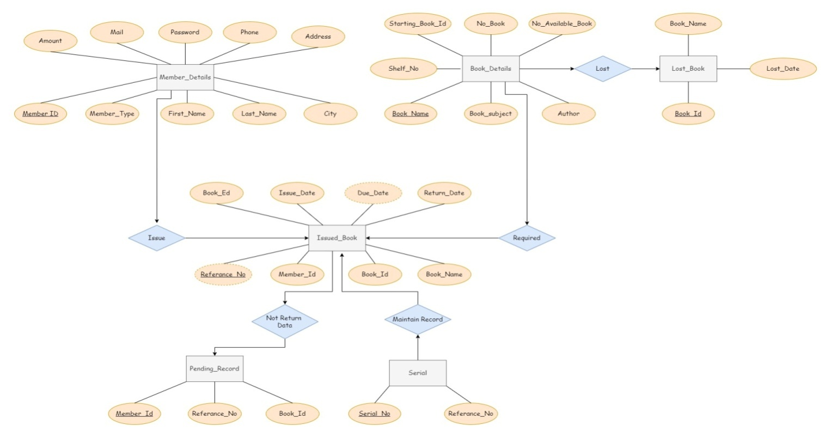**ER Diagram:-**
* **DFD Level – 0 : -**

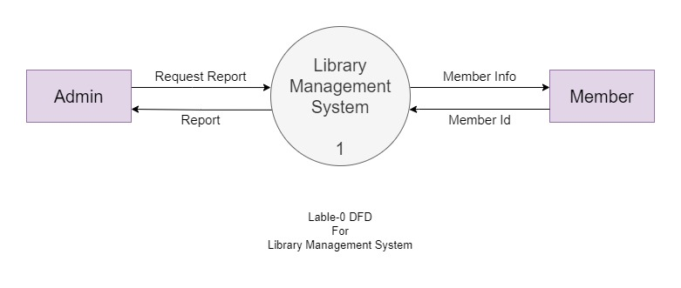

* **DFD Level - 1 :-**

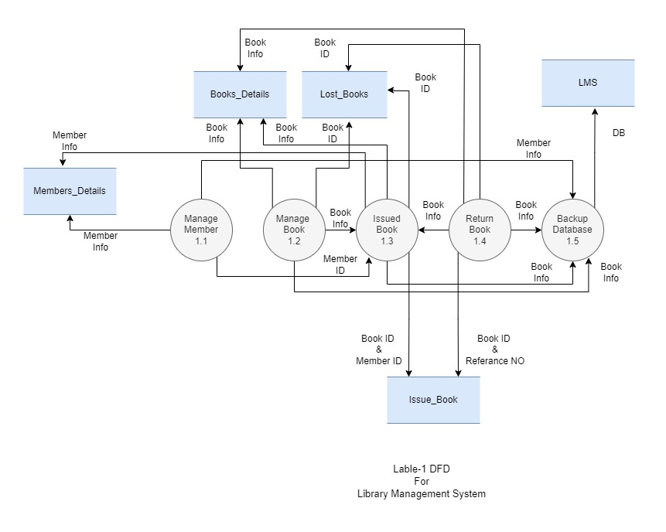

* **DFD Level - 2, For Manage Member, Module - 1.1:-**

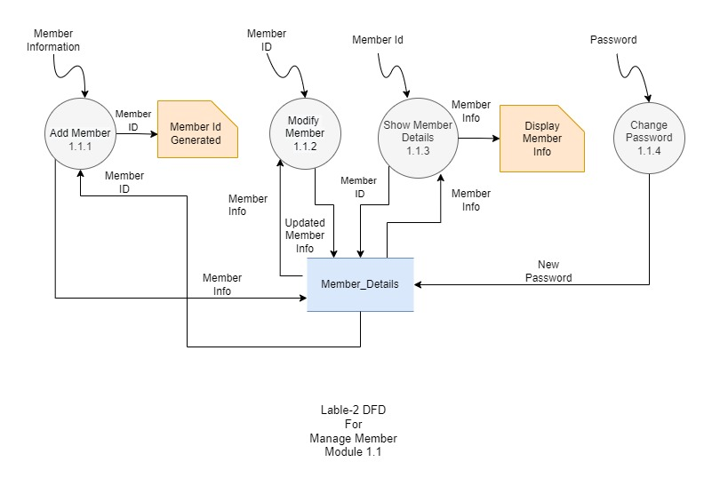

* **DFD Level - 2,** **For Manage Book, Module - 1.2:-**

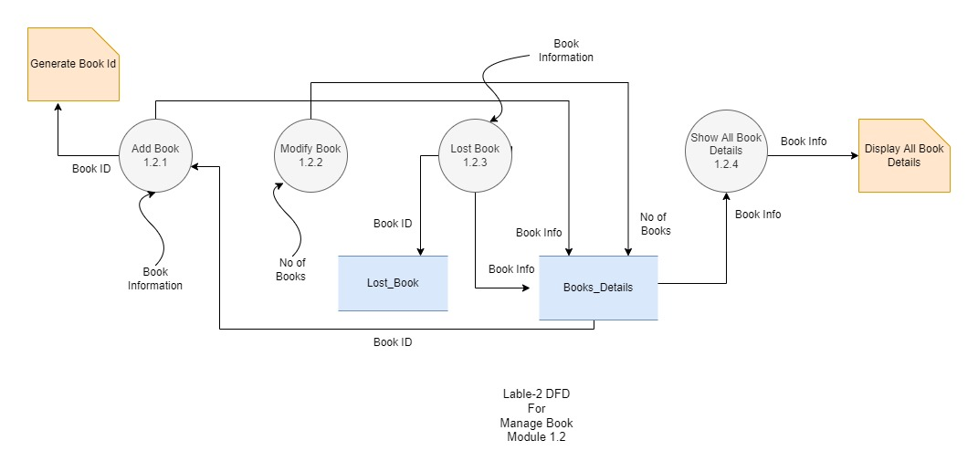

* 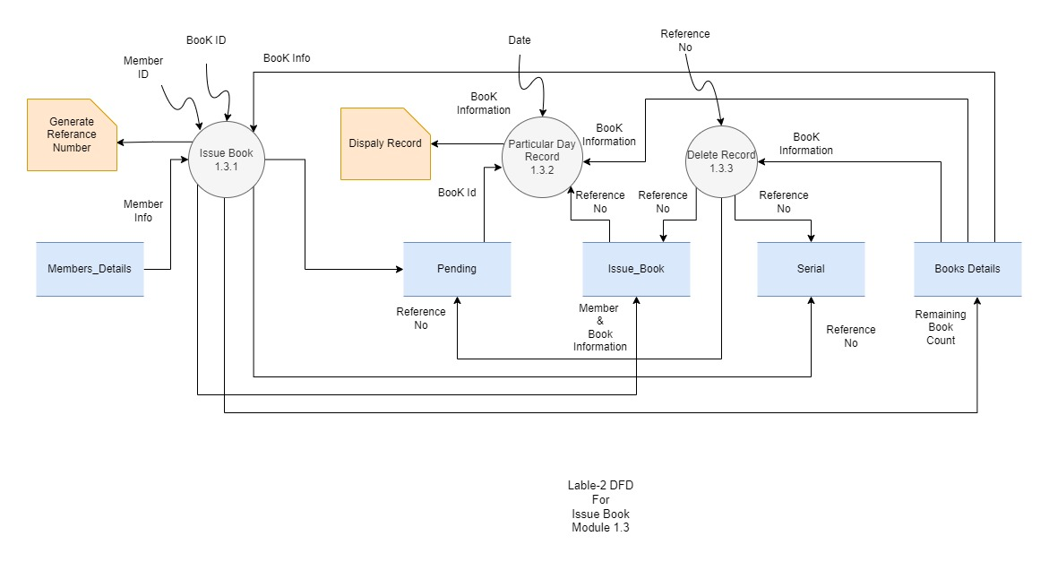**DFD Level - 2, For Issue Book, Module - 1.3:-**
* **DFD Level - 2, For Return Book, Module - 1.4:-**

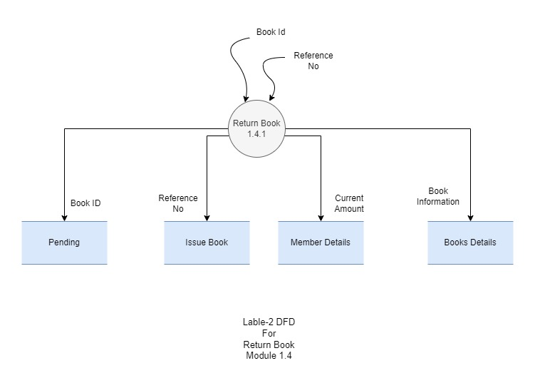

* **Gantt Chart:-**

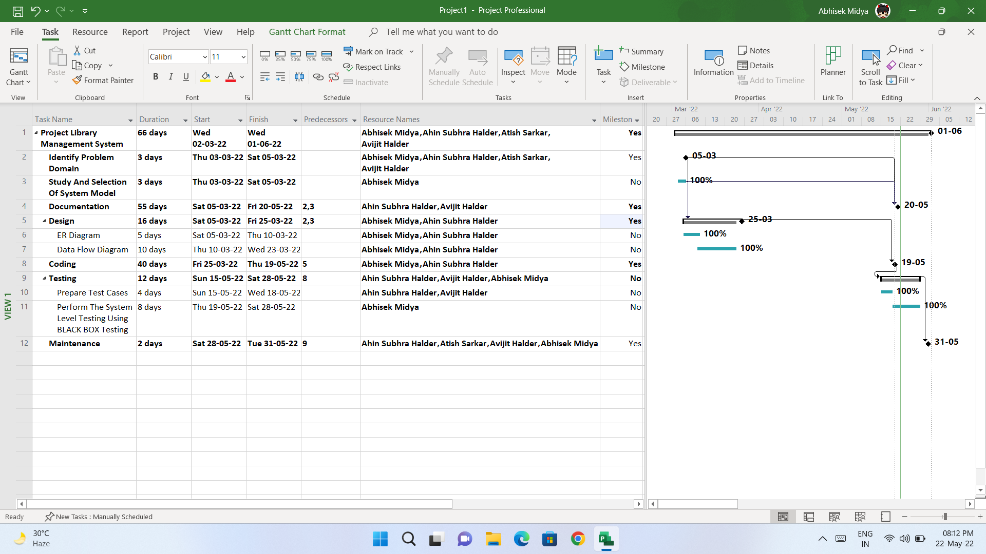

**Implementation**

Implementation is the stage where the theoretical design is turned into a working system. The most crucial stage in achieving a new successful system and in giving confidence on the new system for the users that it will work efficiently and effectively.

The system can be implemented only after thorough testing is done and if it is found to work according to the specification.

It involves careful planning, investigation of the current system and its constraints on implementation, design of methods to achieve the changeover and an evaluation of change over methods apart from planning. Two major tasks of preparing the implementation are education and training of the users and testing of the system.

The more complex the system being implemented, the more involved will be the systems analysis and design effort required just for implementation.

The implementation phase comprises of several activities. The required hardware and software acquisition is carried out. The system may require some software to be developed. For this, programs are written and tested. The user then changes over to his new fully tested system and the old system is discontinued.

**5.1 Client-Side Development:**

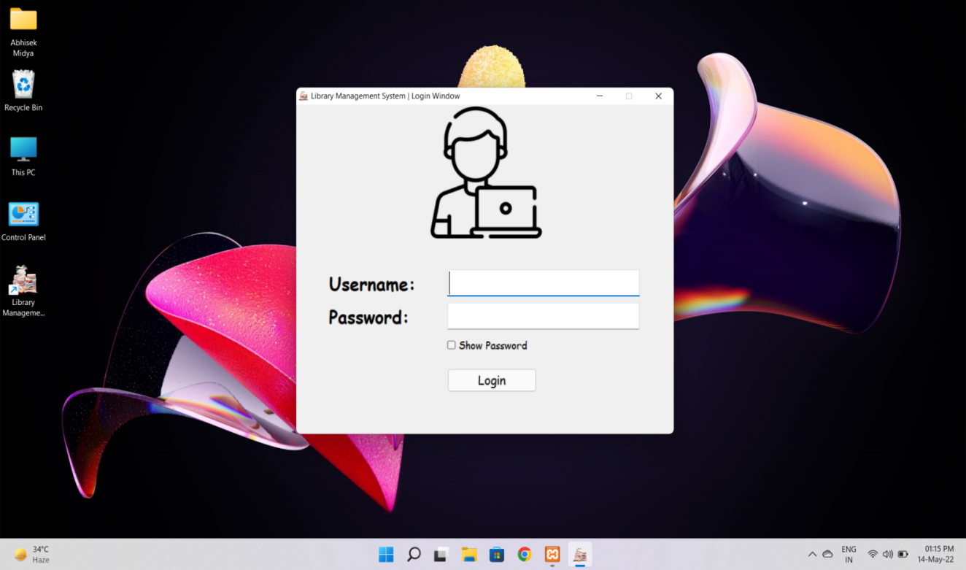**1. Login Page:-**

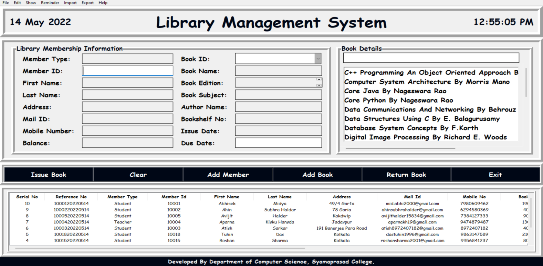**2. Admin Panel:-**

**2.1 Menu-Bar :-**

**2.1.1 File**

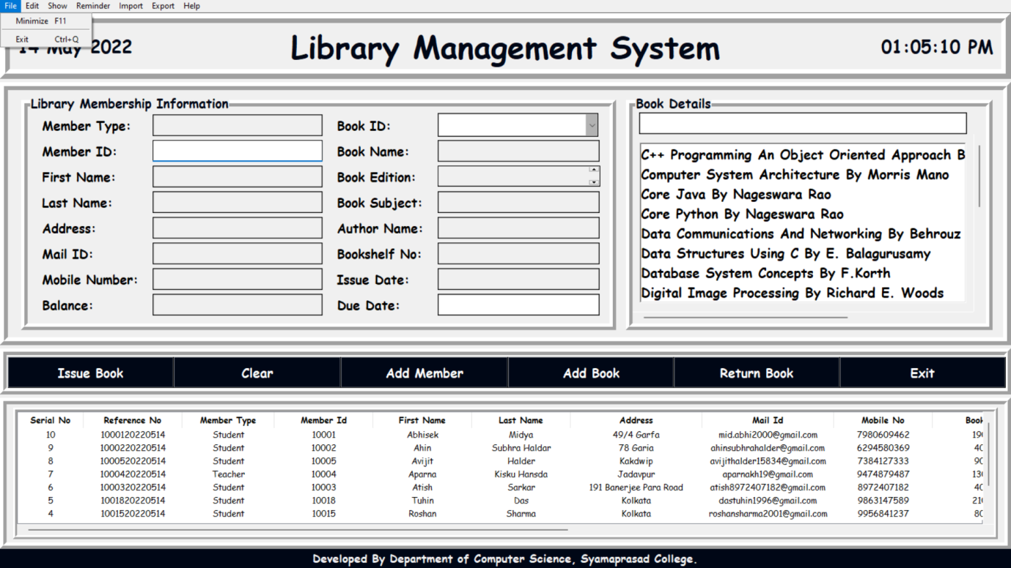

**2.1.2 Edit**

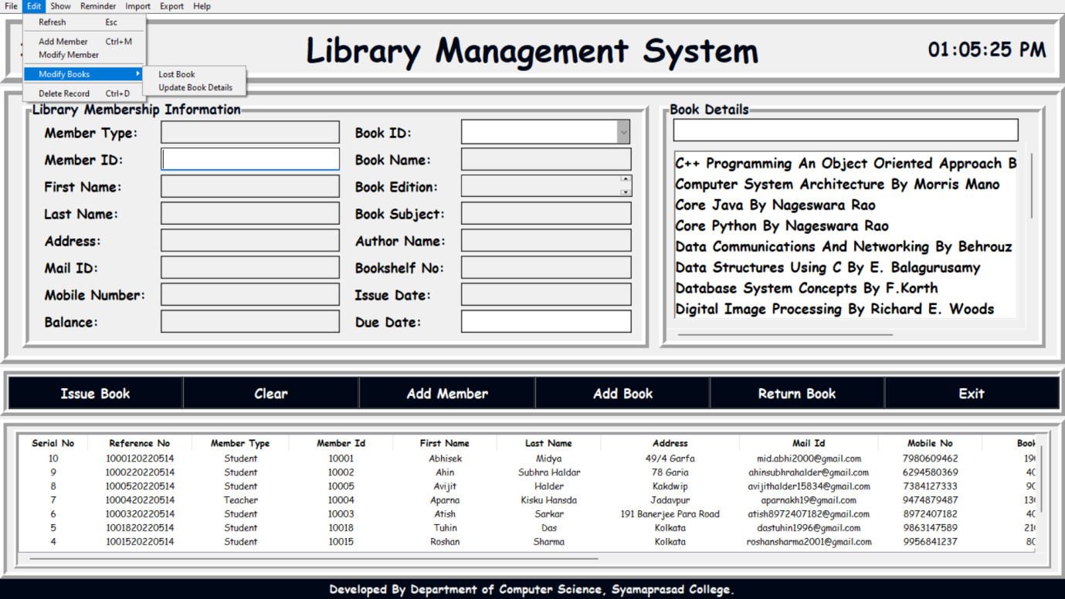

**2.1.3 Show**

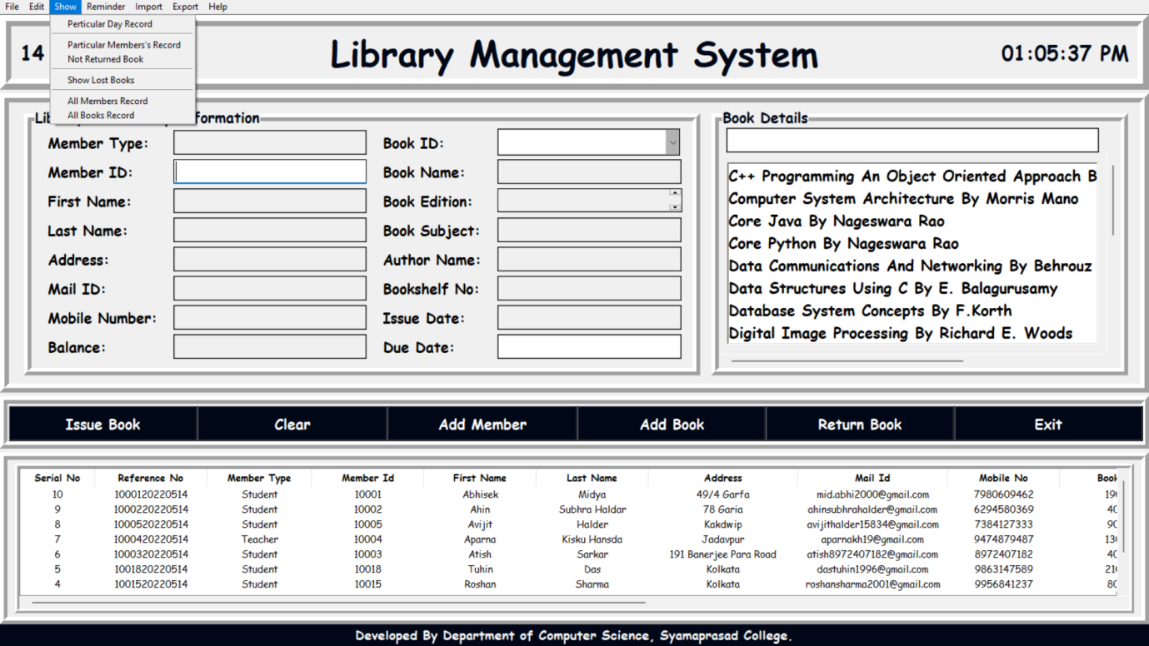

**2.1.4 Reminder**

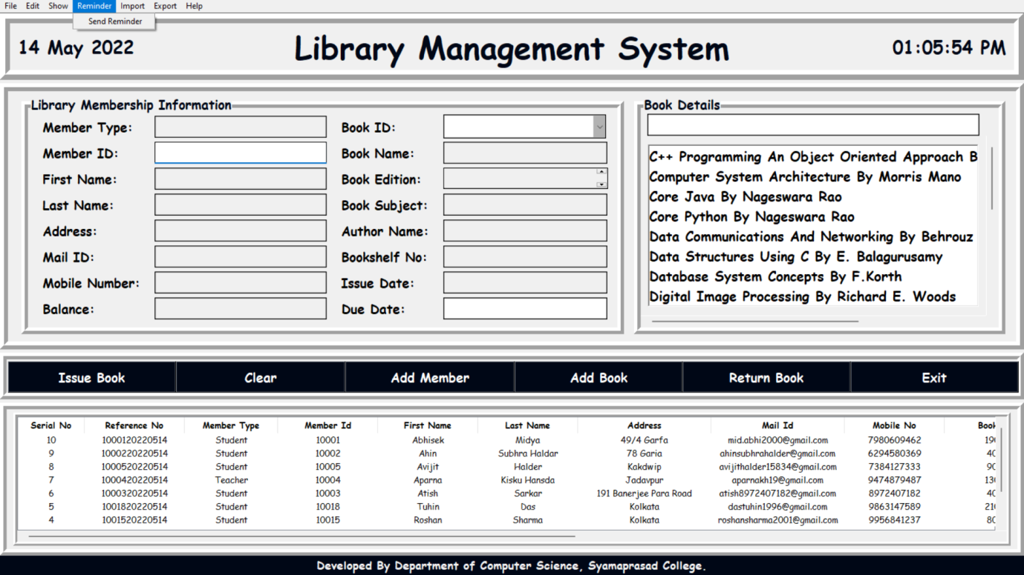

**2.1.5 Help**

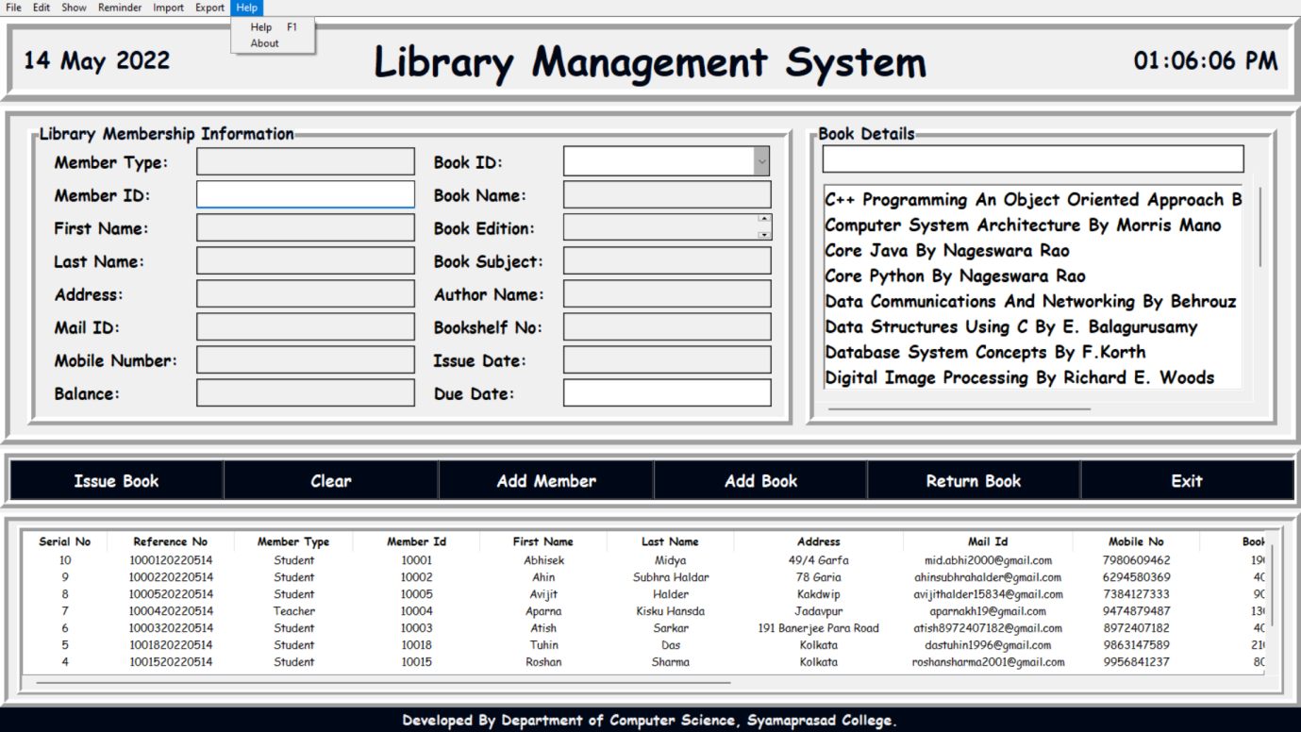

**2.2 All Members Records**

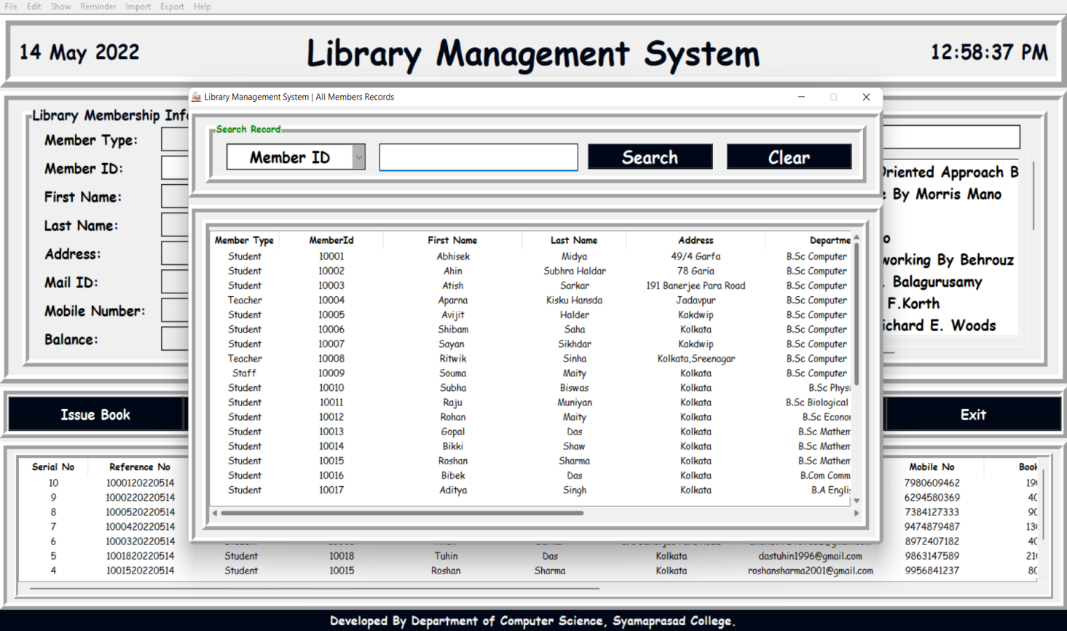

**2.3 All Books Records**

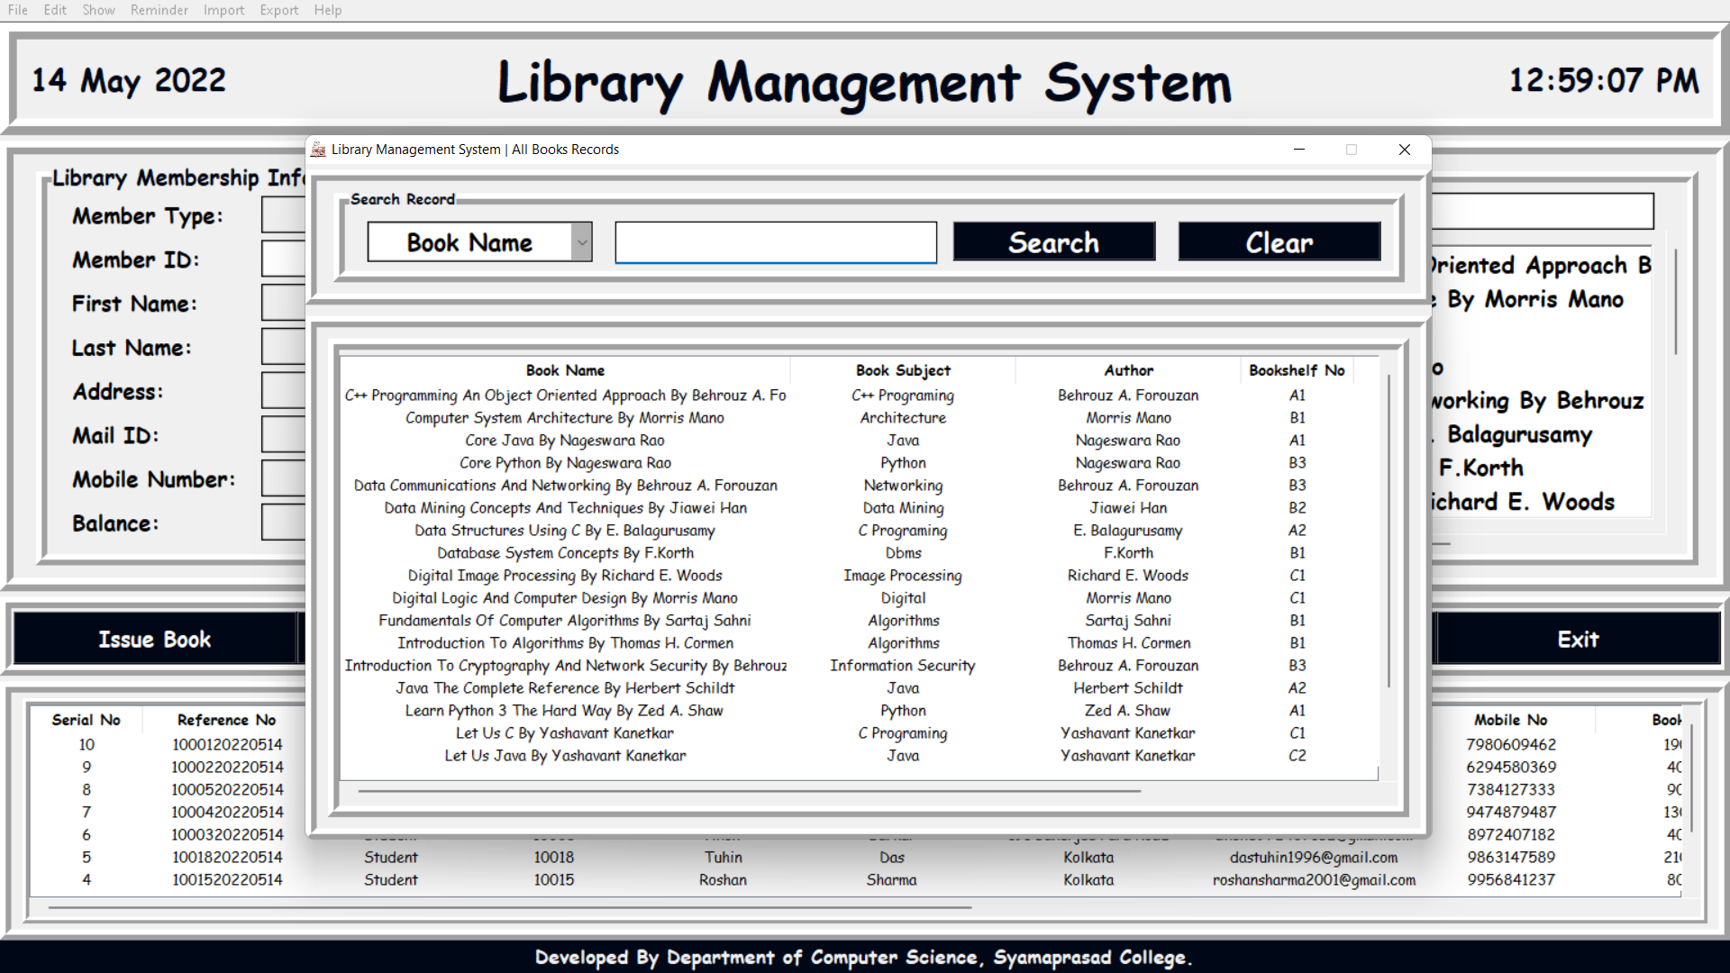

**2.4 Member Registration**

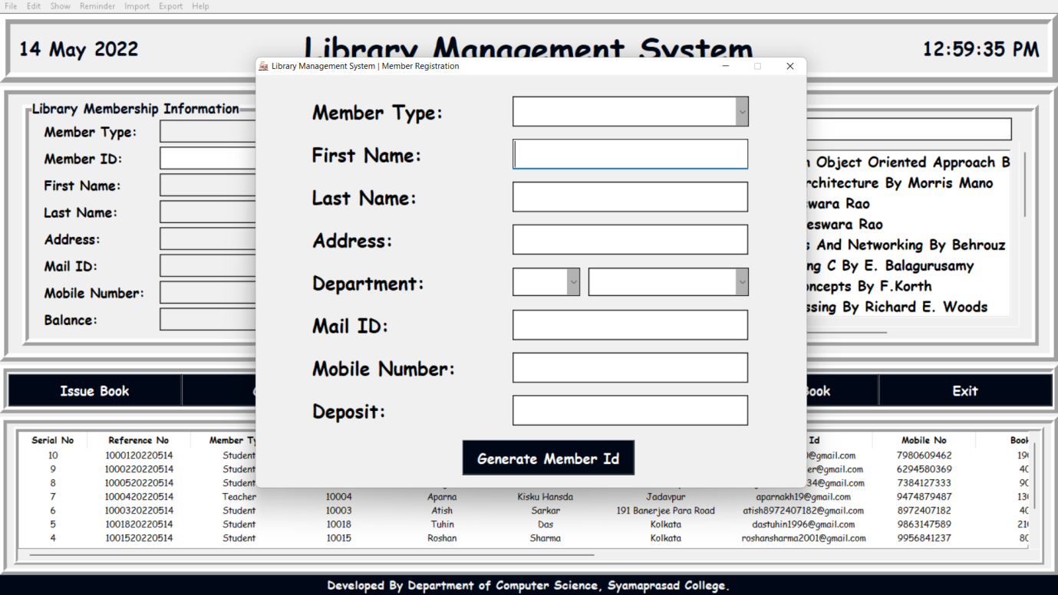

**2.5 Modify Member**

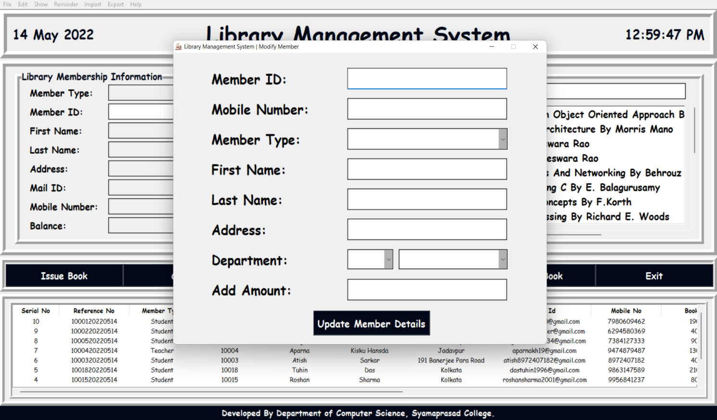

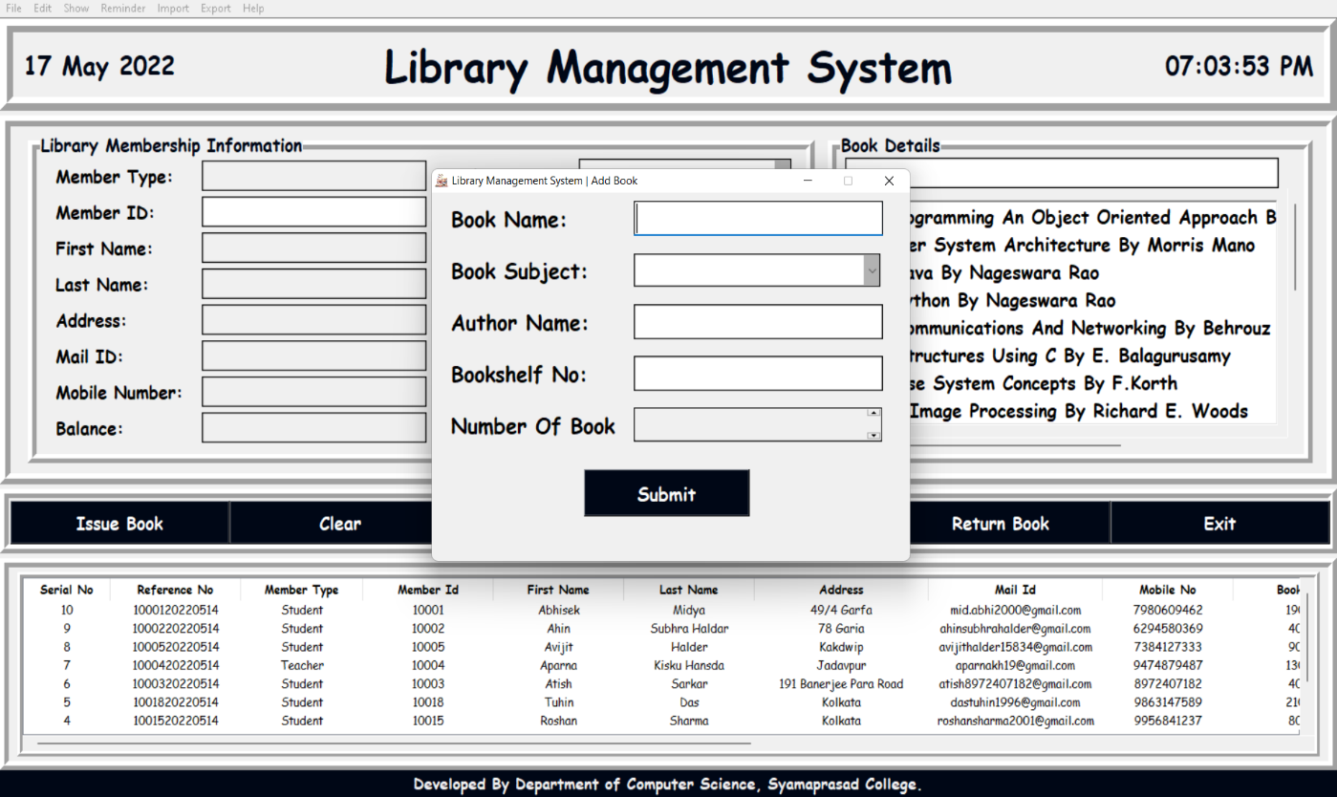**2.6 Add Book**

**2.7 Modify Book**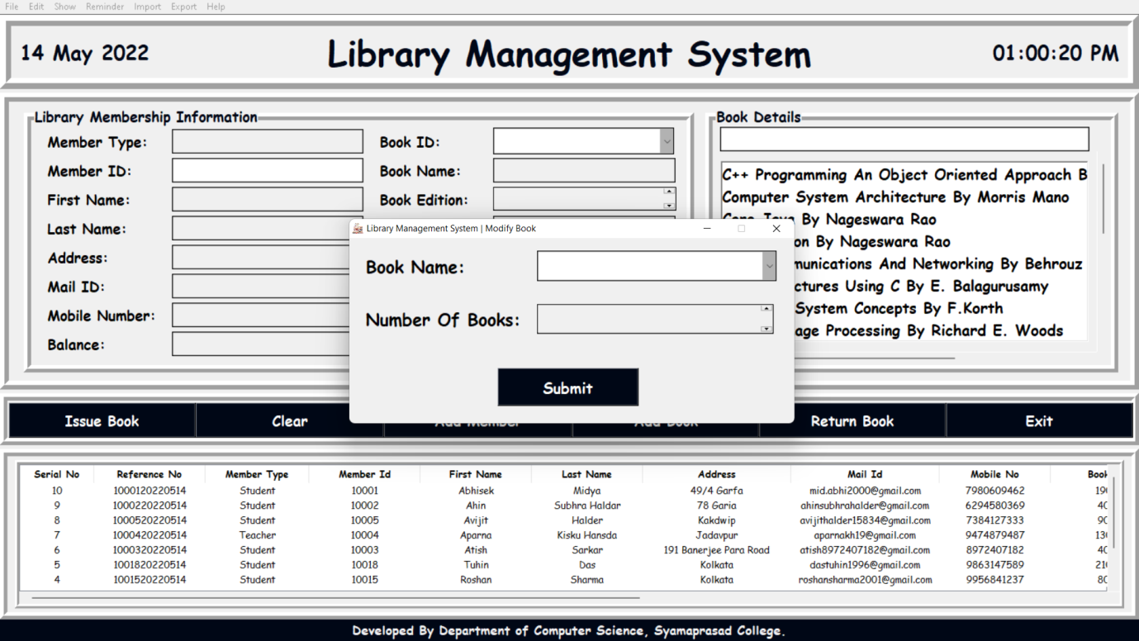

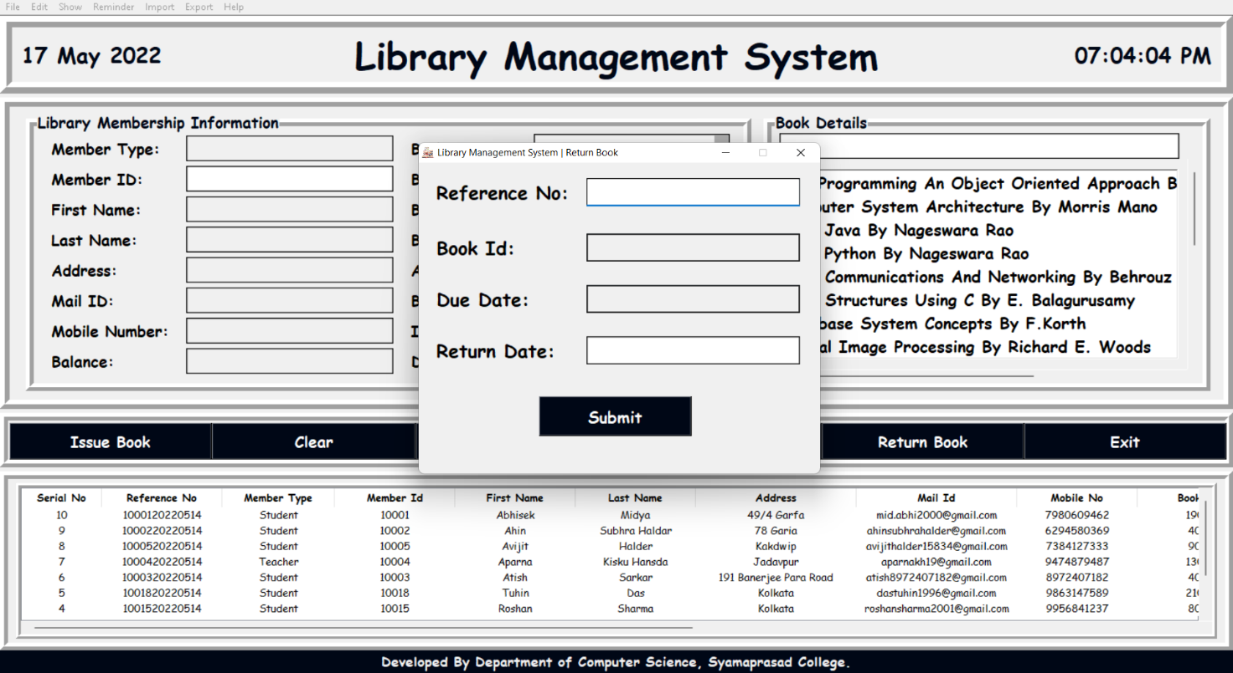**2.8 Return Book**

**2.9 Lost book**  
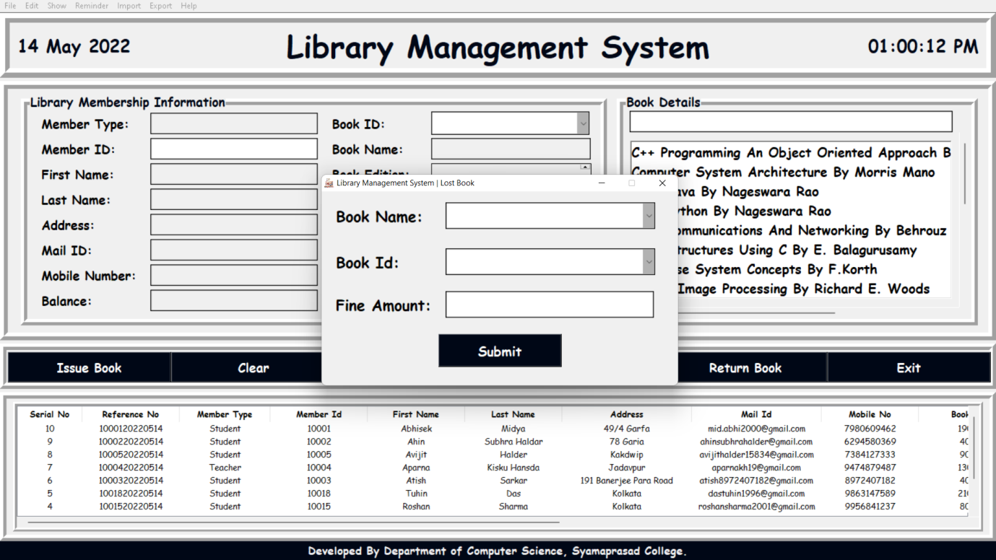

**2.10 Lost Books Record**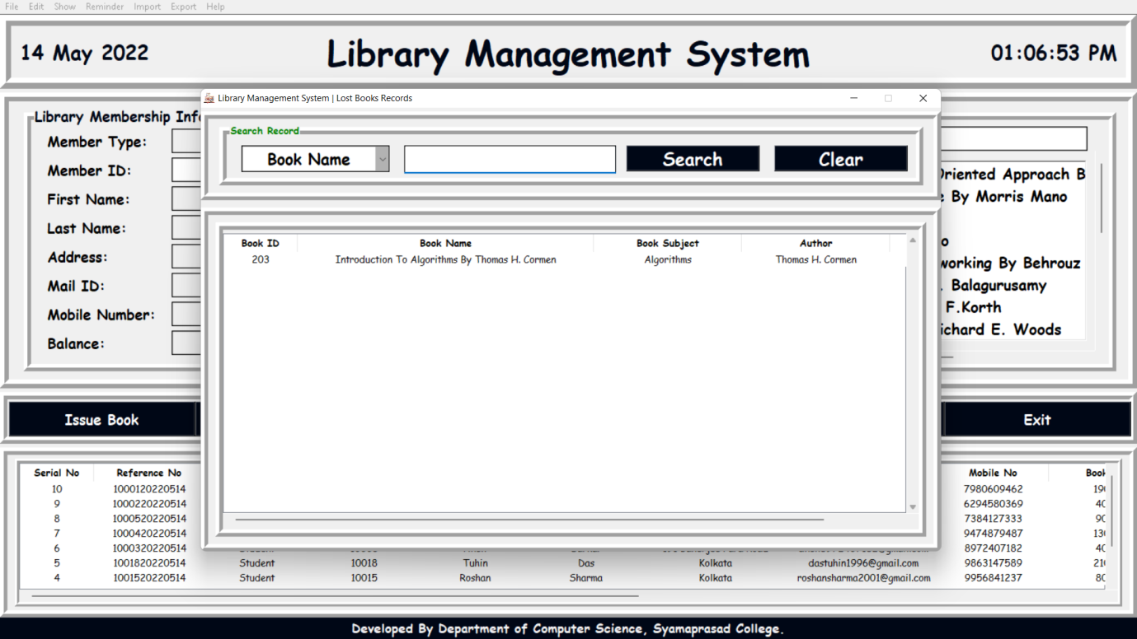

**2.11 Particular Day Record**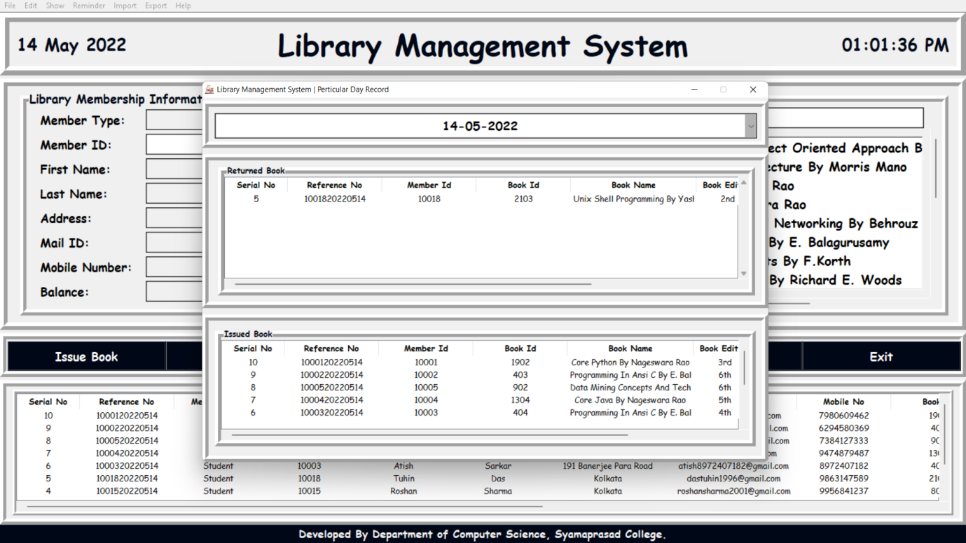

**2.12 Not Returned Book**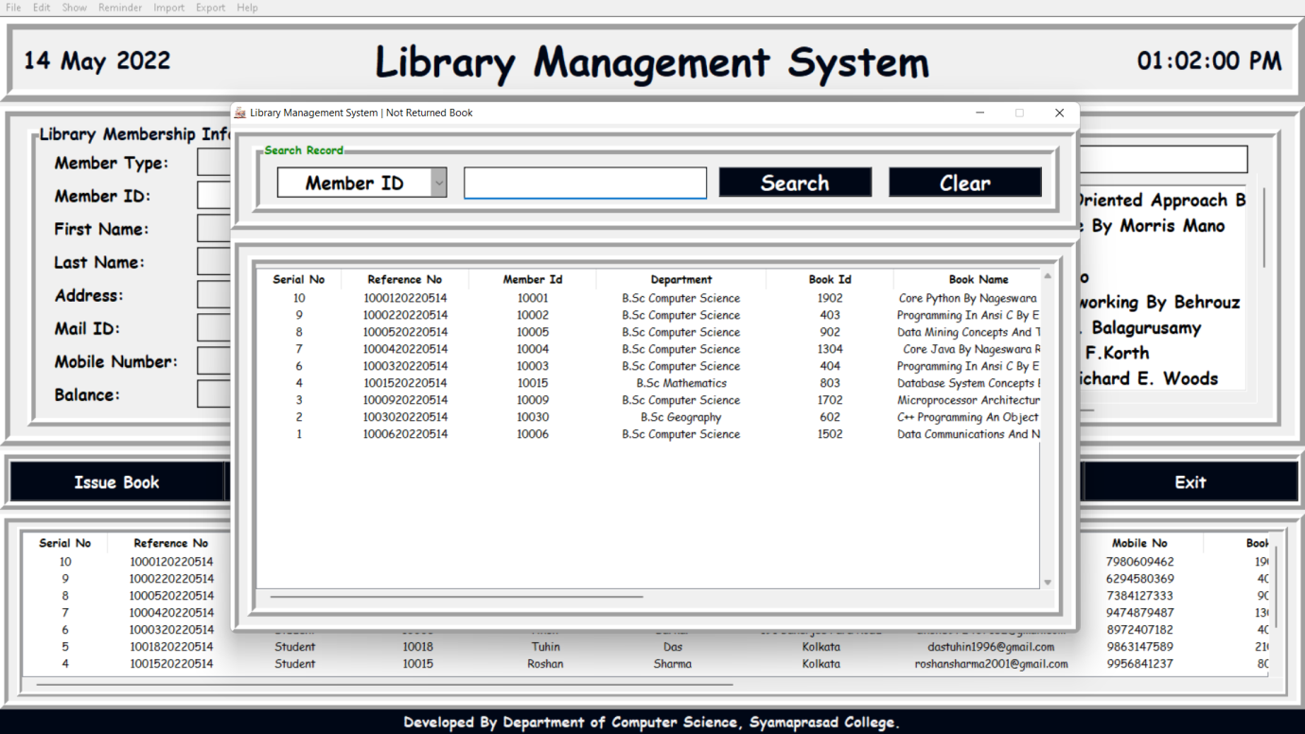

**2.13 Help**  
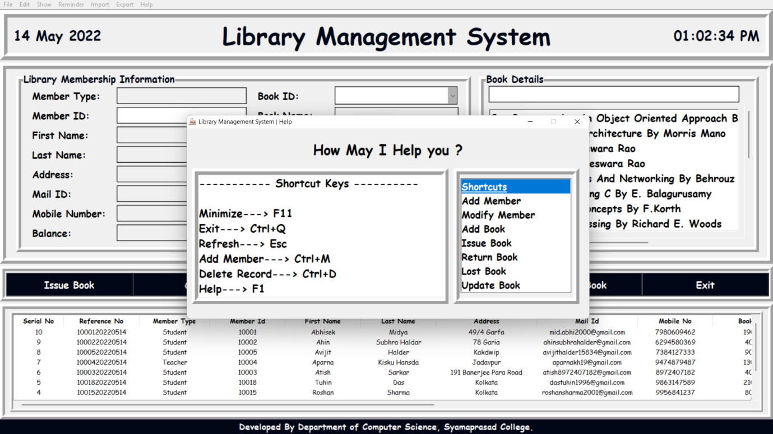

**2.14 About**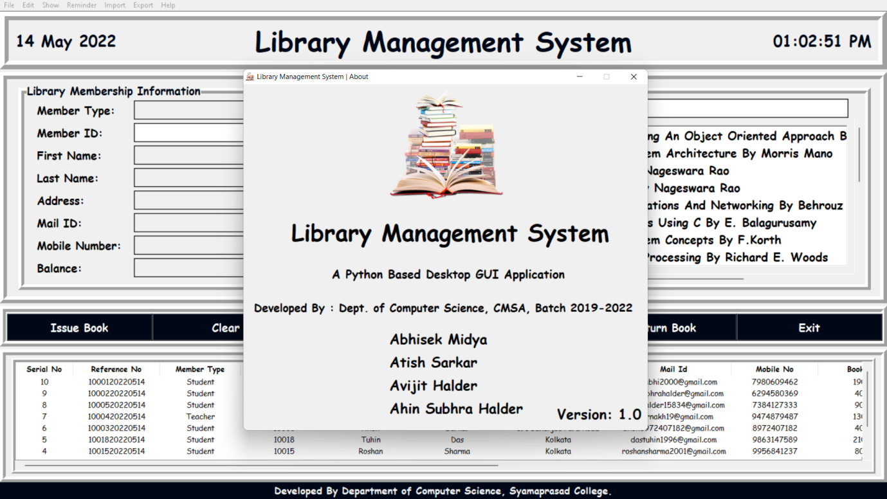

**3. Member/User Panel**  
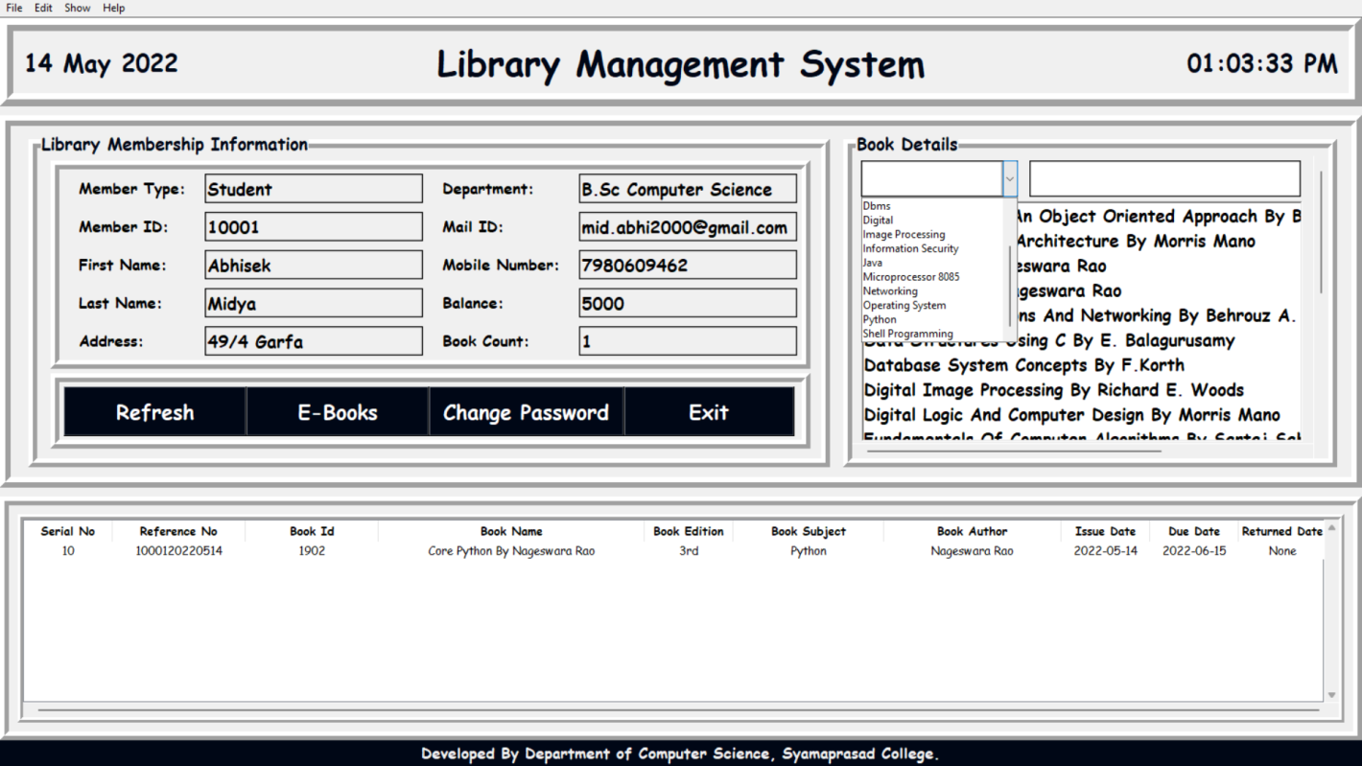

**3.1 Change Password**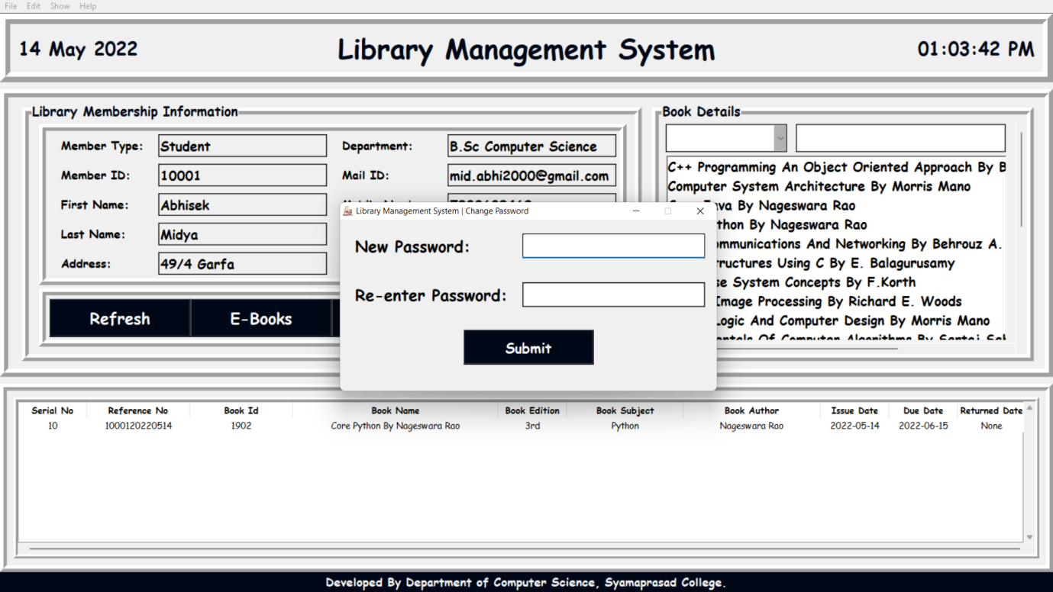

**3.2 E-Book**

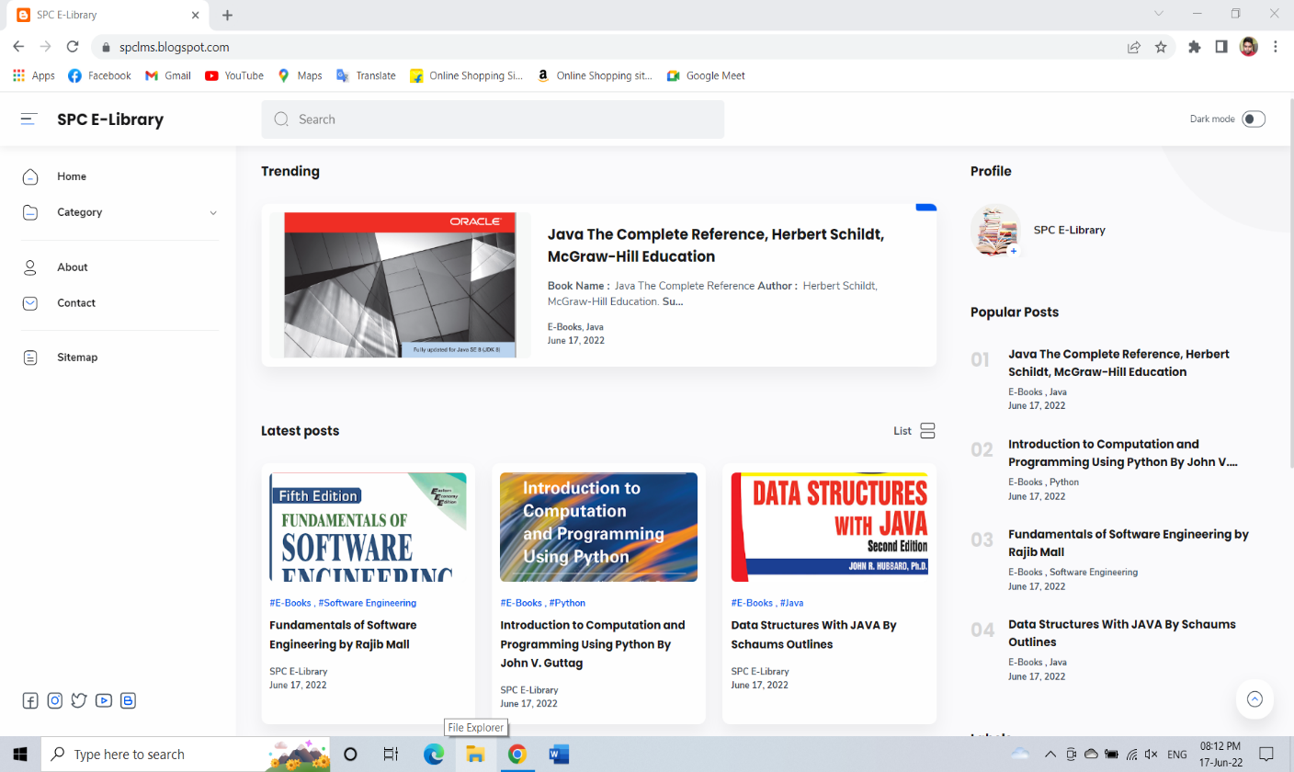

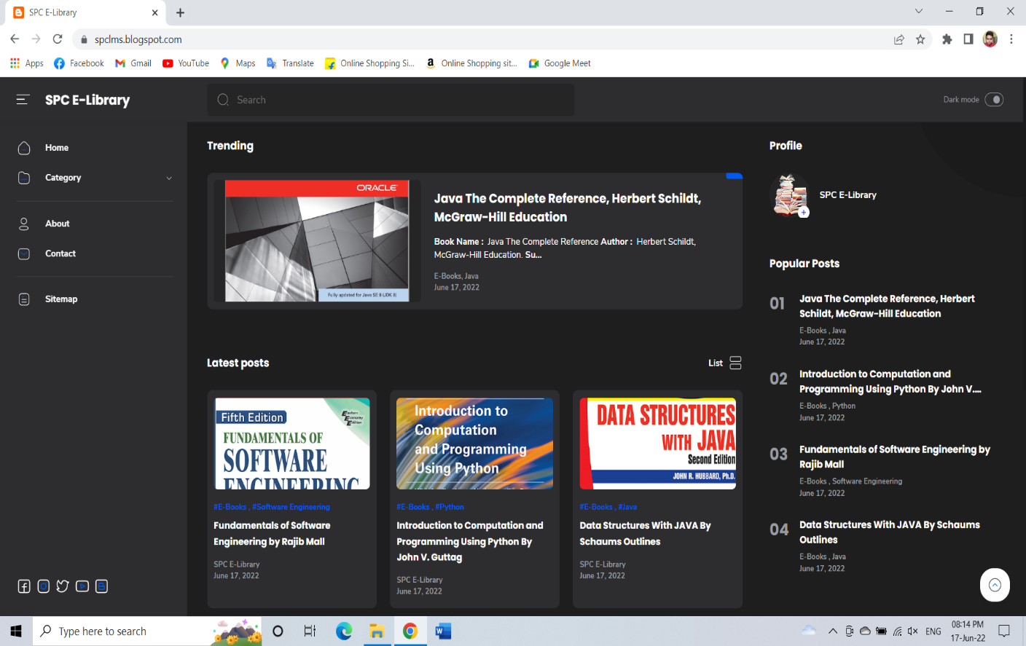

**5.2 Server-Side Development:**

**1. Back-end Database (LMS)**

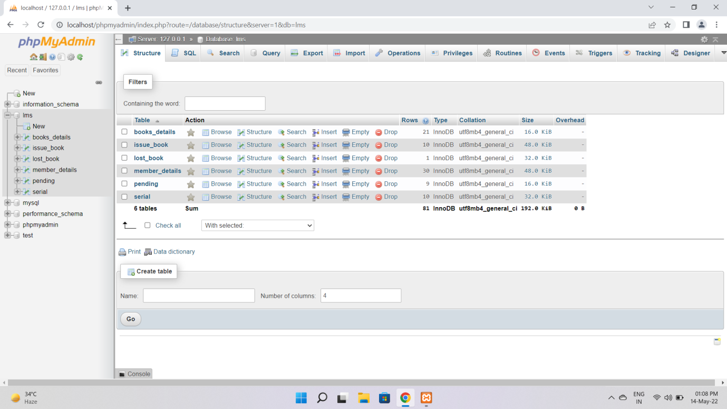

**1.1 books-details**

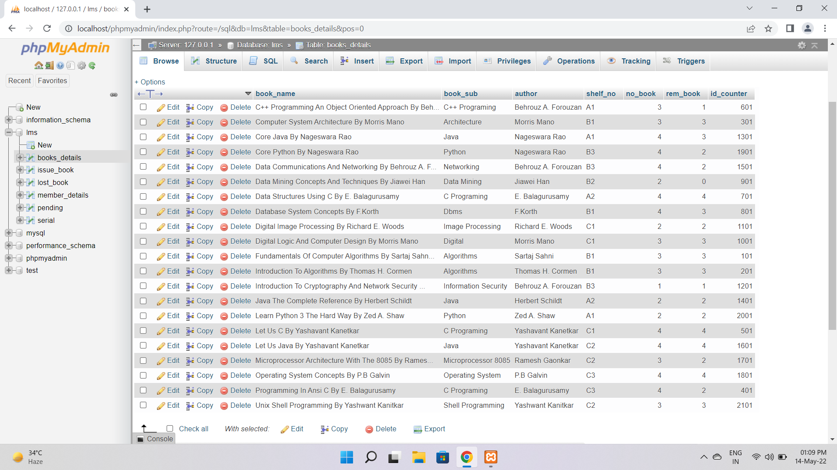

**1.2 issue-book**

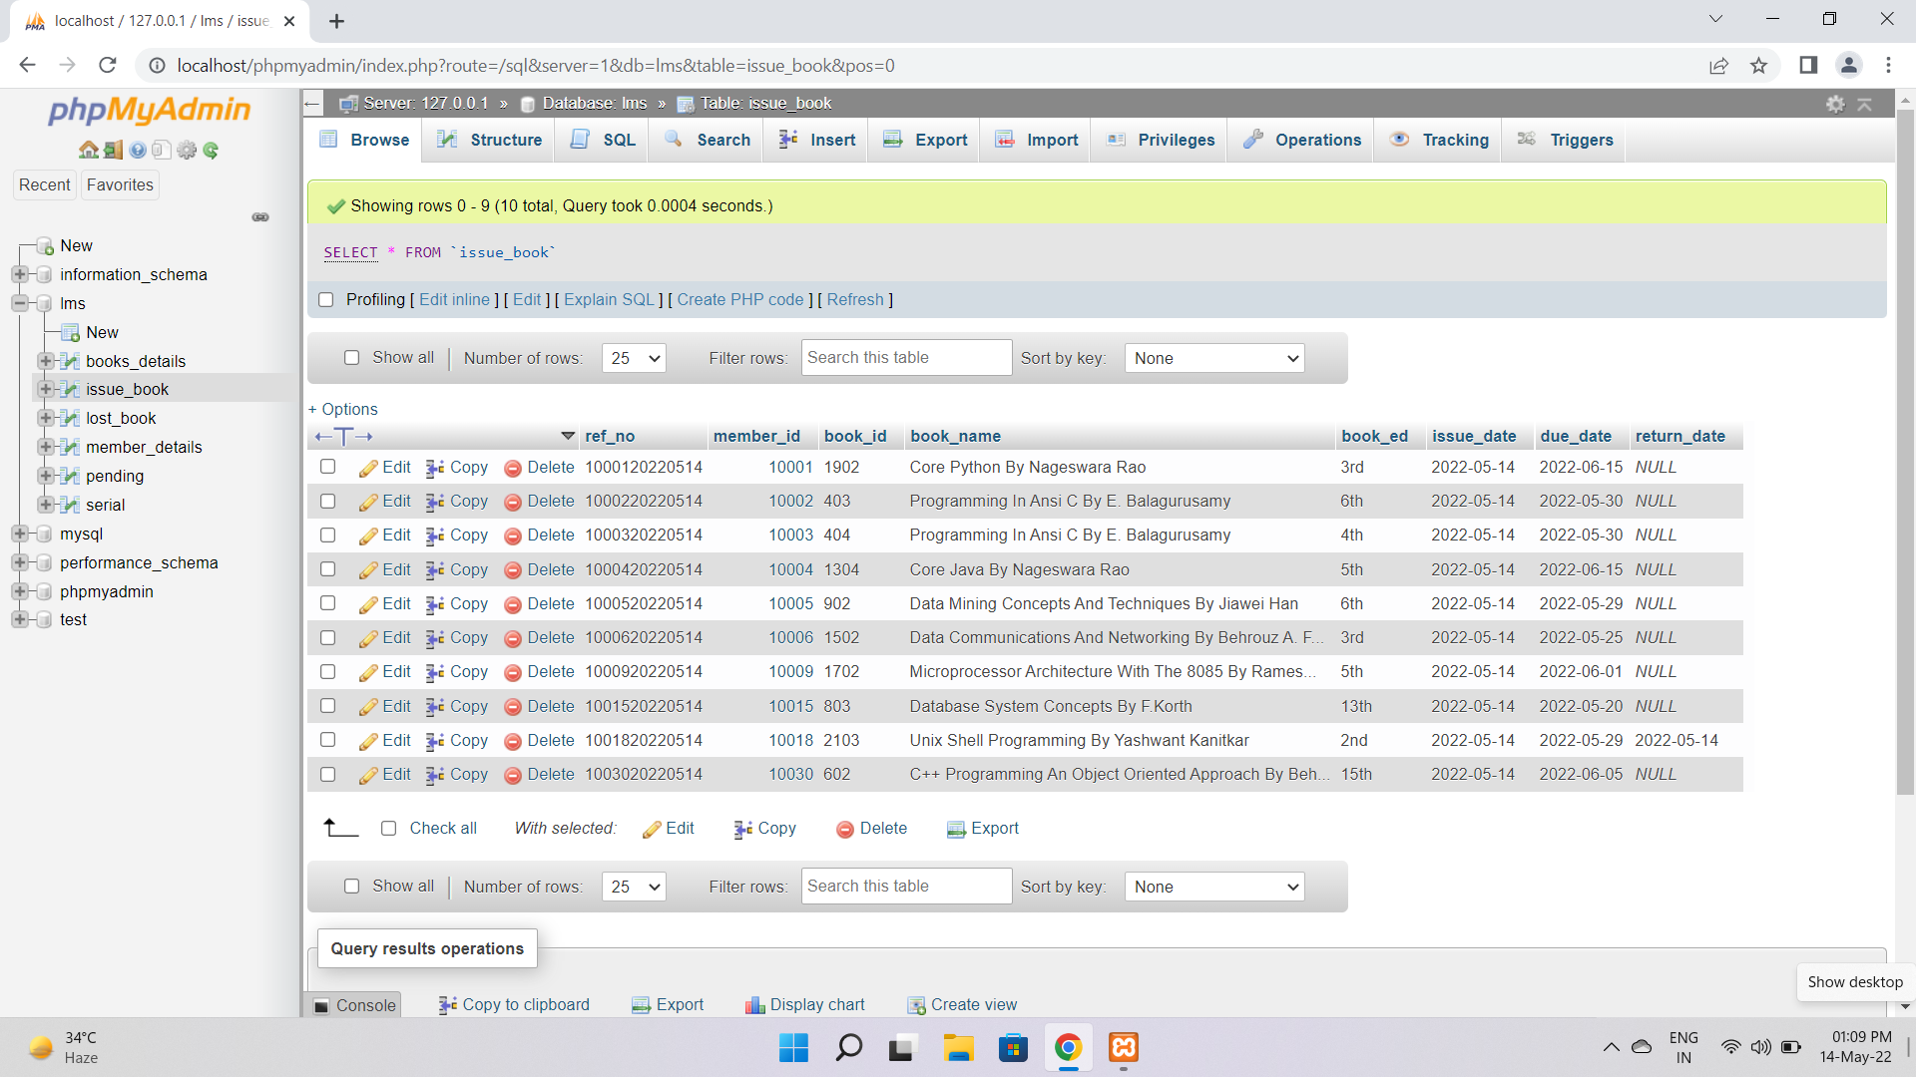

**1.3 lost-book**

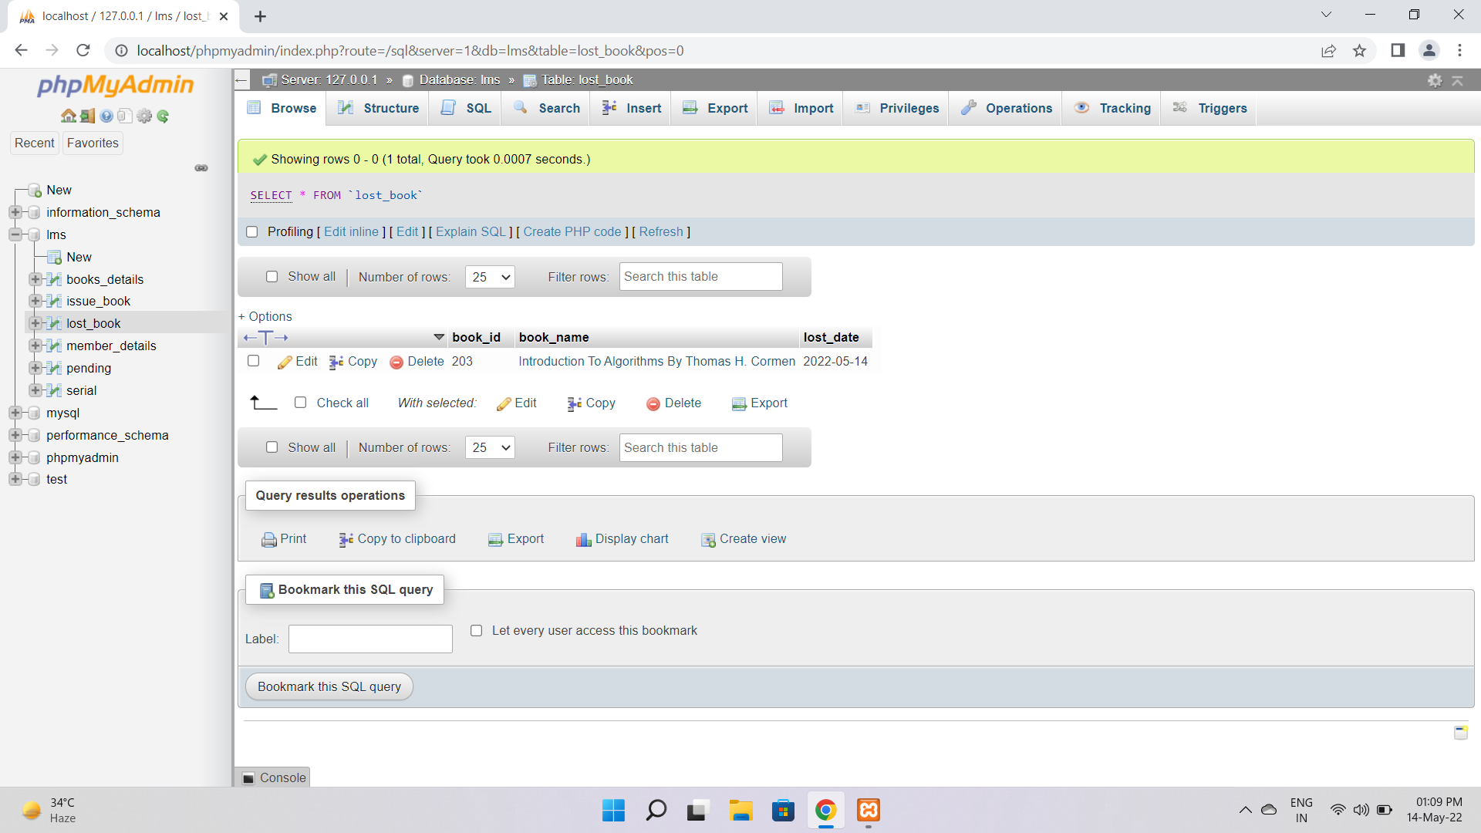

**1.4 member details**

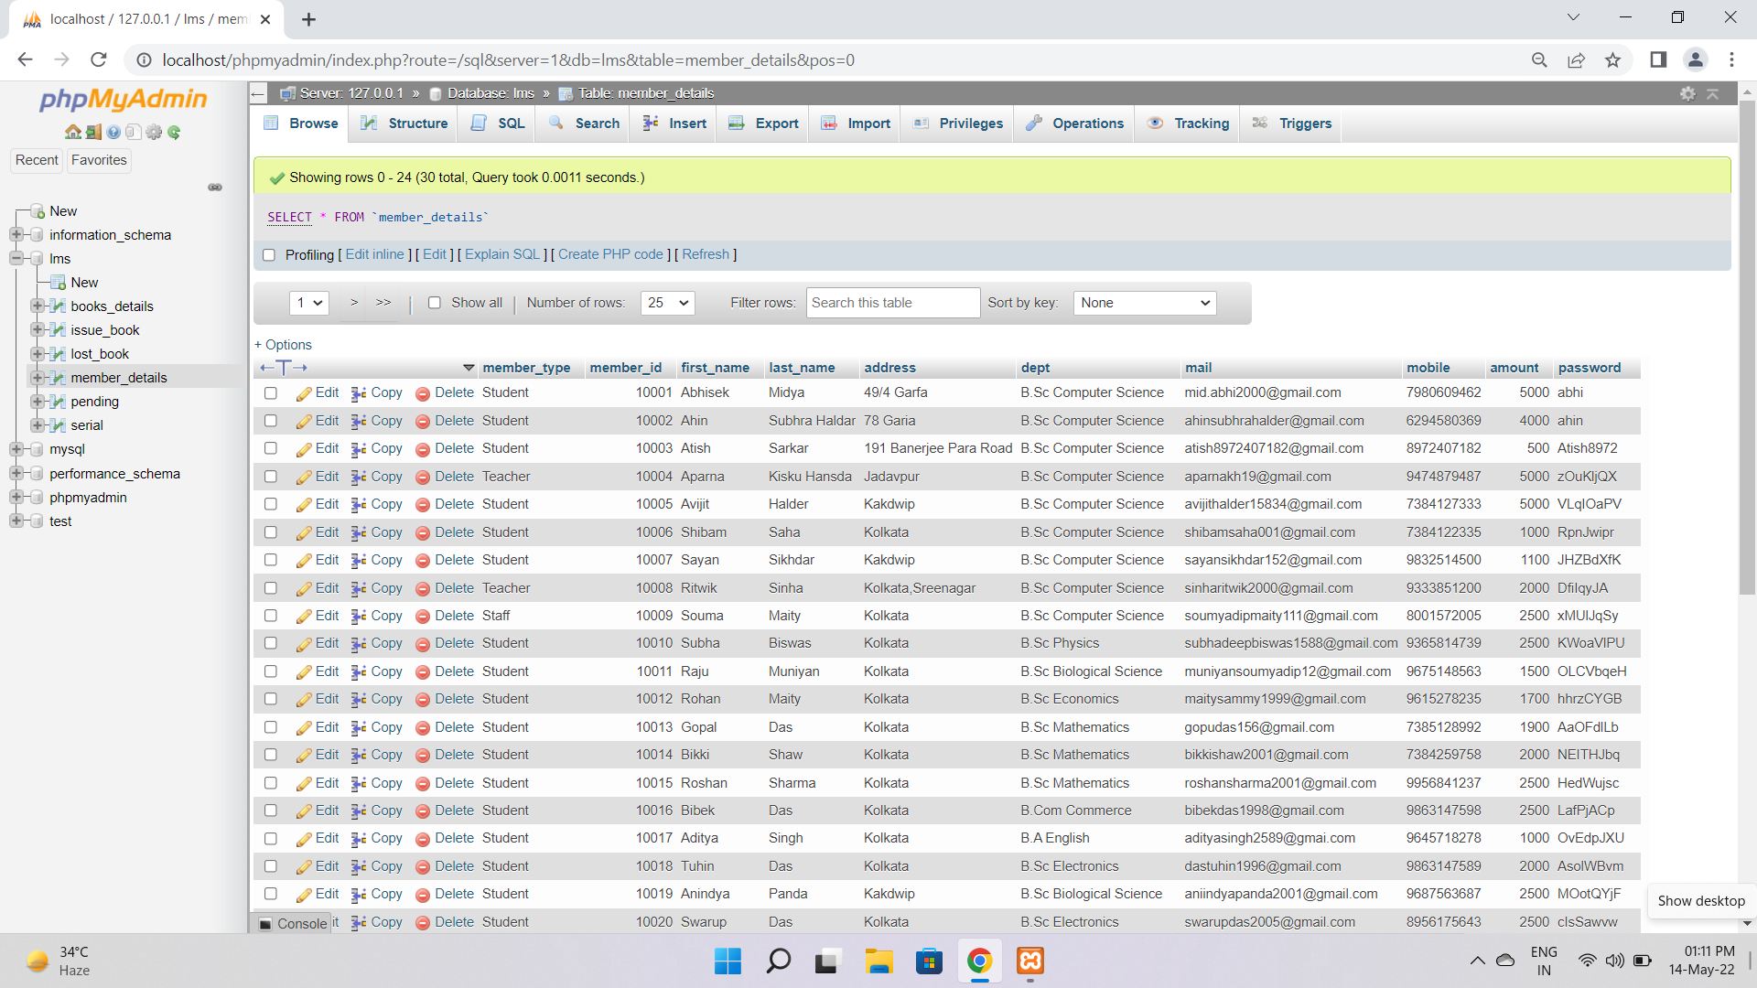

**1.5 pending**

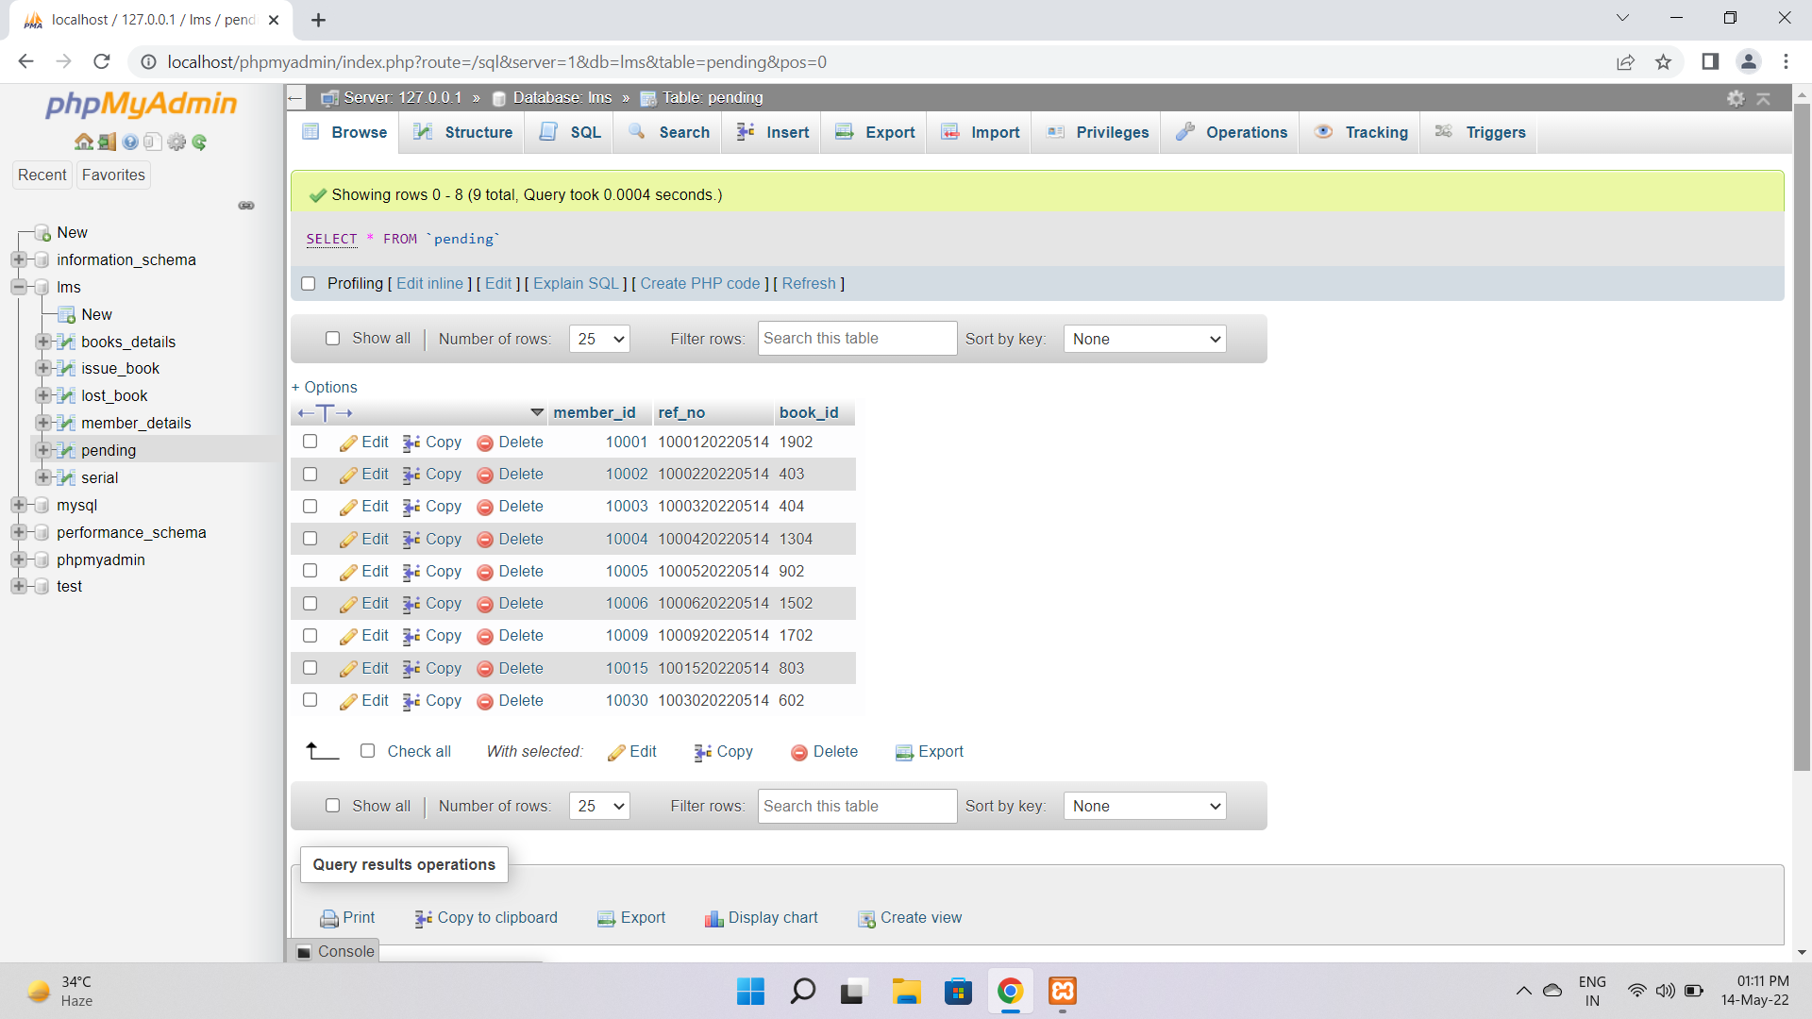

**1.6 serial**

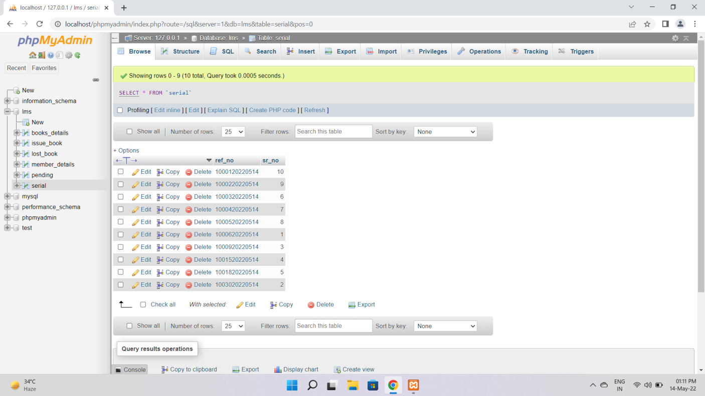

**1.7 Request Form Database**

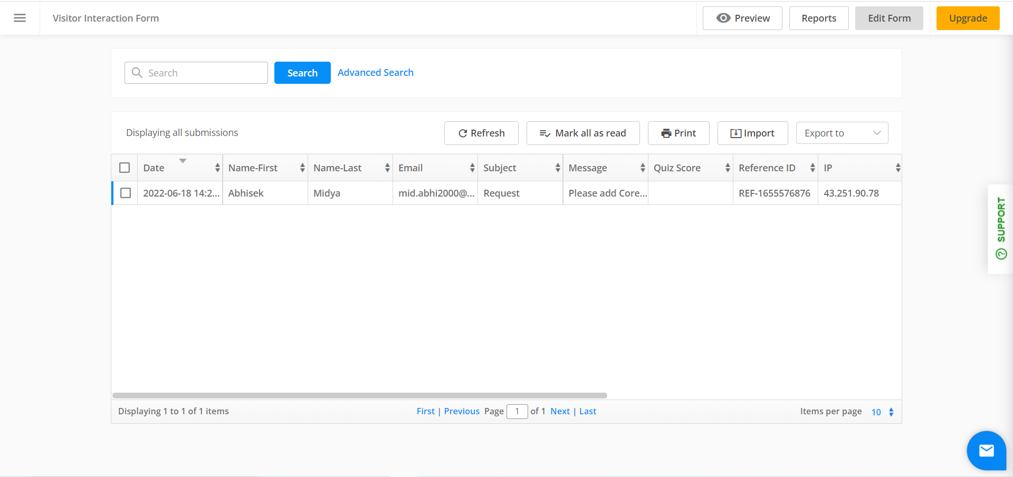

**Results and Discussion**

**6.1 Blackbox Testing:**

1. In the below picture it has shown that we are solving the problem that First Name & Last Name field should take only alphabet.

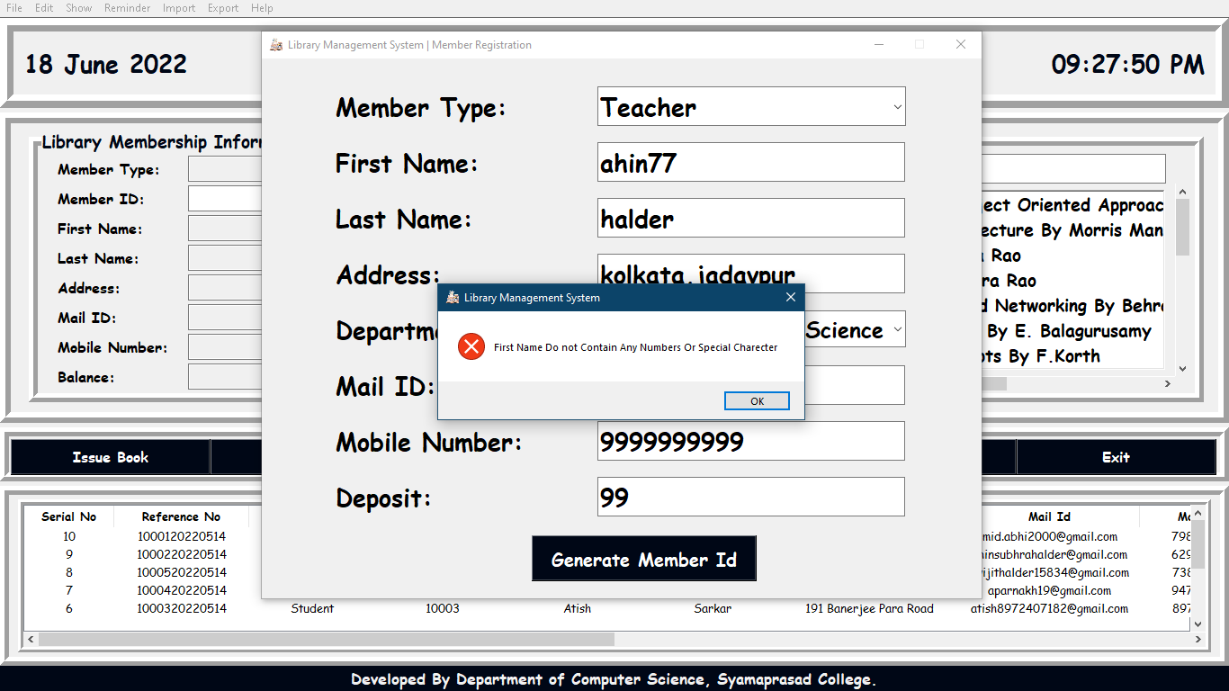

1. In the below picture it has shown that Book due date can’t be less than Issue book date if we enter due date less than issue date than system will give an error message.

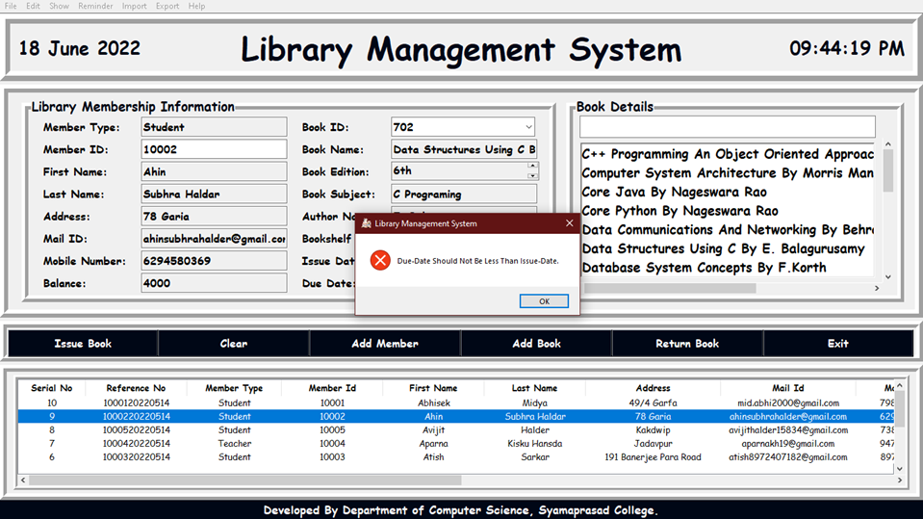

1. In the below picture it has shown that if we enter wrong username and password then it will give an error message.

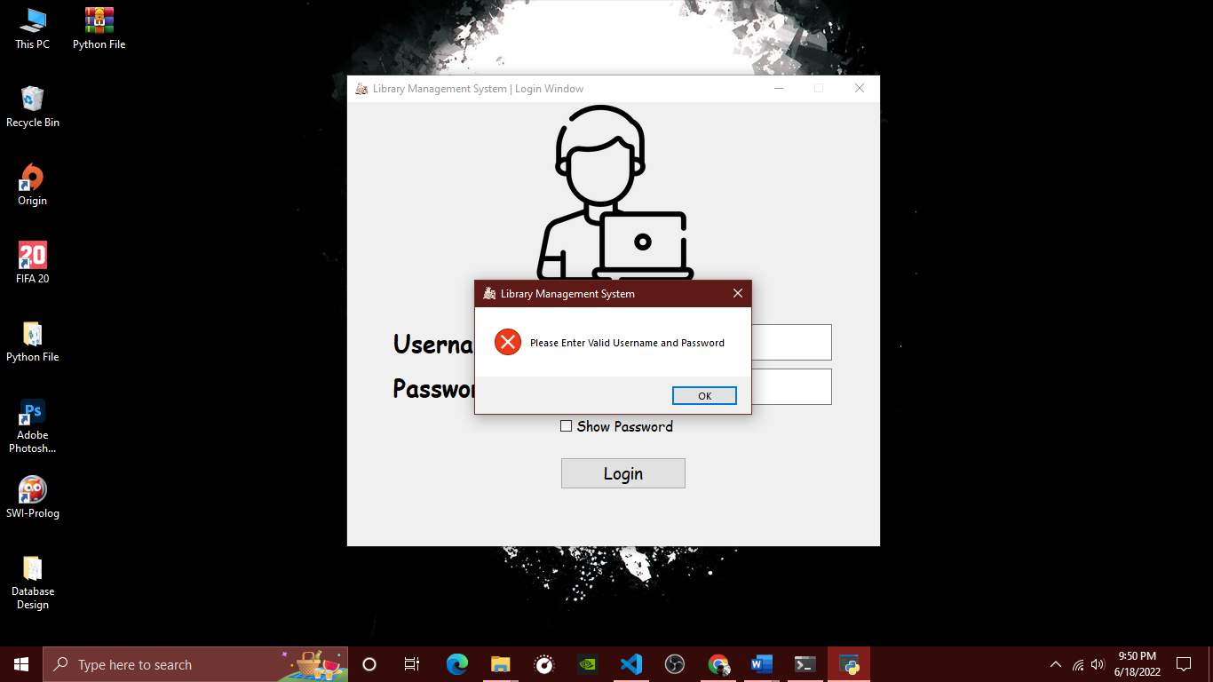

1. In the below picture it has shown that if we add previous recorded book into the database then the system will give an error message.

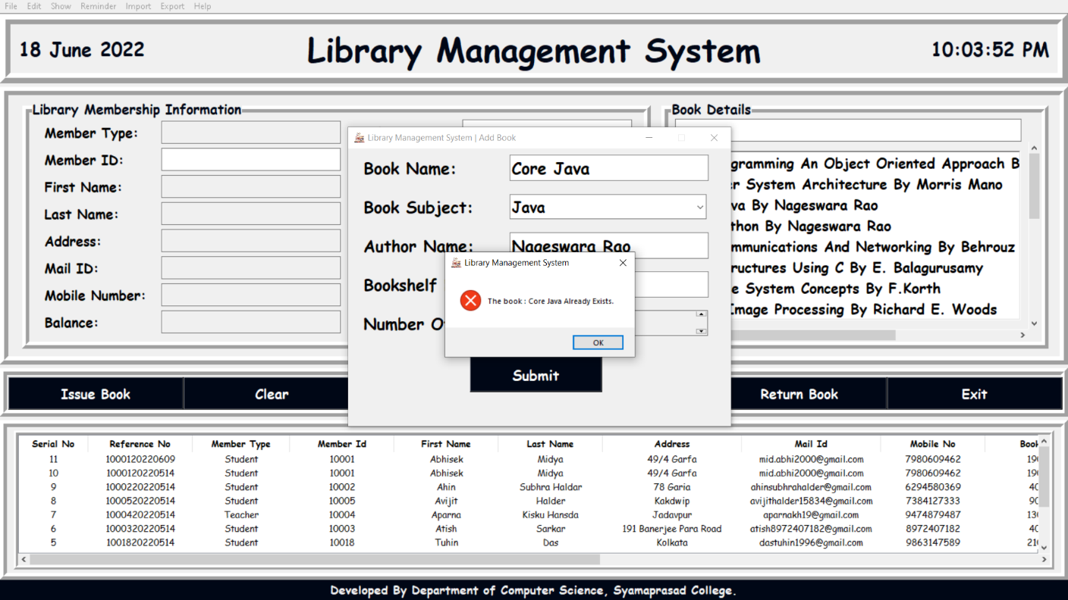

**6.2 Discussion:**

When we design the project there was errors like naming error, wrong date entry, authentication error. We found these errors at the time of testing the software and solved these errors afterwards.

Using this system, we can eliminate the paperwork in library.

We developed a well-organized library borrowing system. It has

minimized the task and the effort being performed by both the librarian and borrowers. It will help the borrowers to easily borrow a book and librarian can manage the records easily.

Overall, this project of ours is being developed to help the students as well as staff of library to maintain the library in the best way possible and it also reduces the human efforts.

**Conclusion**

The package was designed in such a way that future modifications can be done easily. The following conclusions can be deduced from the development of the project.

1. Library Management System of the entire system improves the efficiency.
2. It provides a friendly graphical user interface which proves to be better when compared to the existing system.
3. It gives appropriate access to the authorized users depending on their permissions.
4. It effectively overcomes the delay in communications.
5. Updating of information becomes so easier.
6. System security, data security and reliability are the striking features.
7. The System has adequate scope for modification in future if it is necessary.

**References**

* **PYTHON TUTORIAL --**

[**https://www.pythontutorial.net/tkinter/**](https://www.pythontutorial.net/tkinter/)

* **TKINTER COURSE --**

**https://www.youtube.com/watch?v=Z-aj8jfk_E4**

**https://www.youtube.com/watch?v=YXPyB4XeYLA**

**https://www.youtube.com/watch?v=GODYXAnBDvc**

* **TUTORIAL POINT –-**

**https://www.tutorialspoint.com/python3/python_gui_programming.html**

* **GEEKS FOR GEEKS --**

**https://www.geeksforgeeks.org/python-tkinter-tutorial/**